

**Data Warehousing & Integration**

**IE 6750**

**FALL 2024**

**Milestone-7**

**Group 14**

**AVINASH RANGA**

**SHUBHANG YADAV SANDAVENI**

**ranga.a@northeastern.edu**

**sandaveni.s@northeastern.edu**

**Submission Date: 07-Dec-2024**

**1.Introduction**……………………………………………………………...Page-03

**2.Problem Statement**…………………………….………………………...Page-03

**3.Objectives**………………...…………………….………………………...Page-03

**4.Conceptual Model………………………………………………….…....**Page-04

**5.Logical OLAP Model**………………………….………………………...Page-0**5**

**6.Fact Table**……………………………………...………………..………...Page-05

**7.Dimensions and Attributes**………………...……………….…………...Page-06

**8**.**Hierarchies**………………...………………………………..……………Page-07

**9.Primary & Secondary Event**………………..…………………..………Page-08

**10.OLAP Model Implementation in Postgres**……….……...……...……Page-08

**11.OLAP Operations**……….…………………………………………....…Page-9

**12.Multiple Data Source Implementation in Talend Studio**………….…Page-10

**13.SCD Type II Implementation**………………………………….………Page-11

# **14.****Control Flow**………………………..……………………………..……Page-11

**15.Key Performance Indicator**……………………………………………Page-12

**16.Analytical Dashboard**…………………………………………..………Page-13

**17.Conclusion**……………...………………………………………..……...Page-14

**18.Future Scope**……………...…………………………………...…..……Page-14

# **1.Introduction**

The music streaming industry relies heavily on data-driven insights to enhance user experiences, optimize content delivery, and inform business decisions. This data warehousing project, built on PostgreSQL, establishes a robust analytical infrastructure for a music streaming platform. The warehouse integrates multiple data sources, processes user activity logs, and organizes data into a star schema. The schema consists of dimension tables (UsersDim, ArtistsDim, SongsDim, CityDim, TimeDim, etc.) and a fact table (LISTENING_ACTIVITY) that captures key measures, such as total session duration and subscription type (either free or paid). This setup enables efficient data querying, tracking of user interactions, and supports Slowly Changing Dimensions (SCD) for maintaining historical data.

# **2.Problem Statement**

With the vast amount of user activity generated on music streaming platforms, analyzing and making sense of this data presents a complex challenge. The platform requires a centralized data warehouse to unify data from diverse sources, capture user listening behaviors, and provide a structured foundation for business intelligence (BI) and analytics. Current issues include lack of historical tracking of user subscription changes, difficulty in mapping geographic information, and challenges in extracting granular insights such as session duration by date or location. The goal is to address these challenges by implementing a scalable data warehouse solution that allows for seamless analysis, especially on metrics critical to understanding user behavior and subscription patterns.

# **3.Project Objectives**

The primary objectives of this project are:

1. **Data Integration and Transformation**: Extract, transform, and load (ETL) data from multiple sources, including user activity logs, metadata (like song and artist information), and a data dictionary file for mapping cities and states. Key transformations include extracting dates (Year, Month, Day) from timestamps and parsing location details (City, State, StateCode) from user profiles.

2. **Schema Design and Data Modeling**: Develop a star schema with one fact table (LISTENING_ACTIVITY) and multiple dimension tables (e.g., UsersDim, ArtistsDim, SongsDim, etc.), structured to optimize query performance for business intelligence (BI) needs. This schema will capture key metrics like total session duration and subscription type, enabling efficient analysis of user behaviors.

3. **Handling Slowly Changing Dimensions (SCD)**: Implement SCD Type 1 and Type 2 on the UsersDim table to maintain a historical record of user subscription changes. The status will update to "Active" for paid subscriptions and "Inactive" for free ones, providing insight into subscription history over time.

4. **Measure Calculation**: Calculate key metrics, such as total session duration per user and categorizing subscription types (0 for free, 1 for paid), to support BI and analytics teams in evaluating user engagement and revenue potential.

# **4.Conceptual Model**

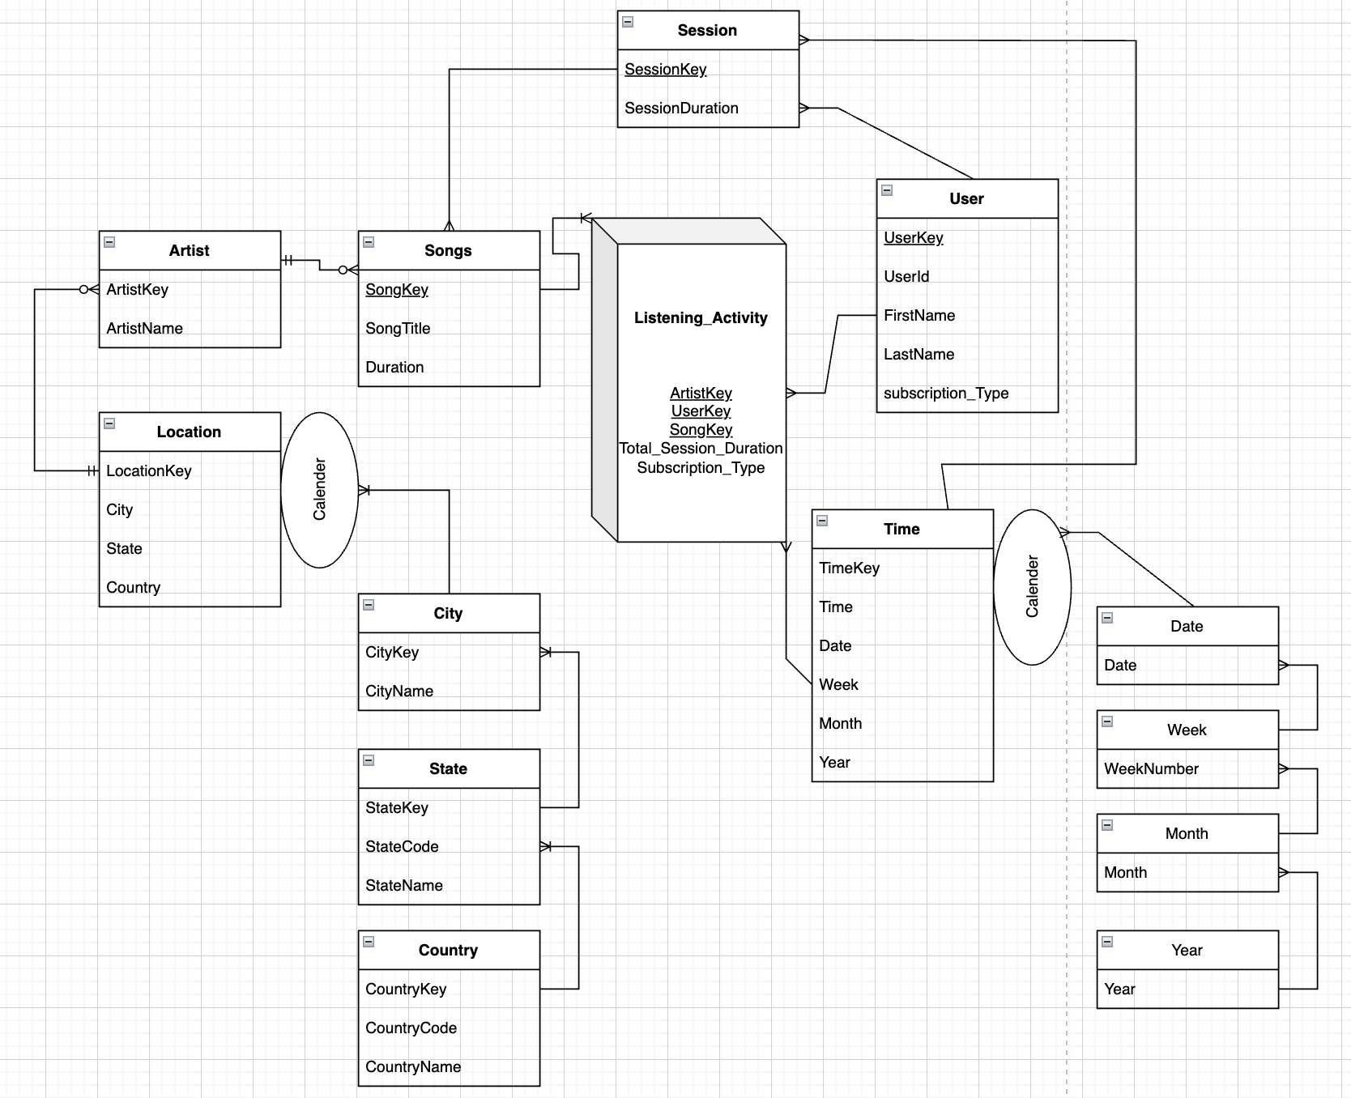

# **5.Logical OLAP Model**

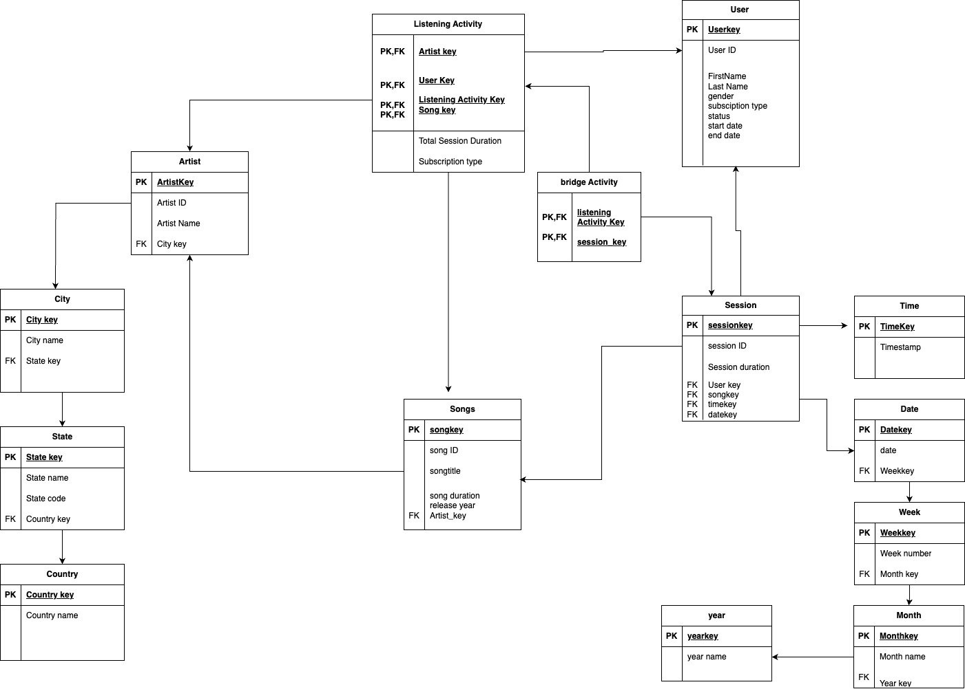

# **6.Fact Table: LISTENING_ACTIVITY**

#### **Measures:**

1. **Total_Session_Duration**: The total duration a user listens to songs in a session (primary measure).
2. **Subscription_Type**: Used to categorize Free vs. Paid activity.

### 

### 

# 

# 

# **7.Dimensions and Attributes**

#### **1. UsersDim (User Dimension)**

* Attributes:
  + User_ID (Primary Key)
  + Gender
  + DateOfBirth
  + User_Agent (e.g., Windows, Android, Mac)
  + Location_Name

#### **2. SessionsDim (Session Dimension)**

* Attributes:
  + SessionKey (Primary Key)
  + DateKey (Foreign Key to DateDim)
  + UserKey (Foreign Key to UsersDim)

#### **3. SongsDim (Song Dimension)**

* Attributes:
  + SongKey (Primary Key)
  + Genre
  + ArtistKey (Foreign Key to ArtistsDim)
  + Album
  + Song_Length

#### **4. ArtistsDim (Artist Dimension)**

* Attributes:
  + ArtistKey (Primary Key)
  + ArtistName
  + CityKey (Foreign Key to CityDim)

#### **5. CityDim (City Dimension)**

* Attributes:
  + CityKey (Primary Key)
  + CityName
  + StateKey (Foreign Key to StateDim)

#### **6. StateDim (State Dimension)**

* Attributes:
  + StateKey (Primary Key)
  + StateName
  + CountryKey (Foreign Key to CountryDim)

#### **7. DateDim (Date Dimension)**

* Attributes:
  + DateKey (Primary Key)
  + Date
  + WeekKey(Foreign Key to WeekDim)

#### **8. WeekDim**

* Attributes (for each dimension):
  + WeekKey (Primary Key)
  + WeekNumber
  + MonthKey(Foreign Key to MonthDim)

#### **9. MonthDim**

* Attributes (for each dimension):
  + MonthKey (Primary Key)
  + Month
  + YearKey(Foreign Key to YearDim)

#### **10. YearDim**

* Attributes (for each dimension):
  + YearKey (Primary Key)
  + CalenderYear

# **8.Hierarchies**

1. Year → Month → Week → Day
2. Country → State → City

#### 

# **9.Primary & Secondary Event**

#### **Primary Event:**

* **User playing a song**:
  + This is the main activity recorded in the LISTENING_ACTIVITY table. Each play event updates the Total_Session_Duration and Song_Play_Count.

#### **Secondary Event:**

* **User subscribing to a paid plan**:
  + Indicated through the Subscription_Type attribute and directly impacts measures and dimensions like Total_Session_Duration and song preference trends.

# **10.OLAP Model Implementation in Postgres**

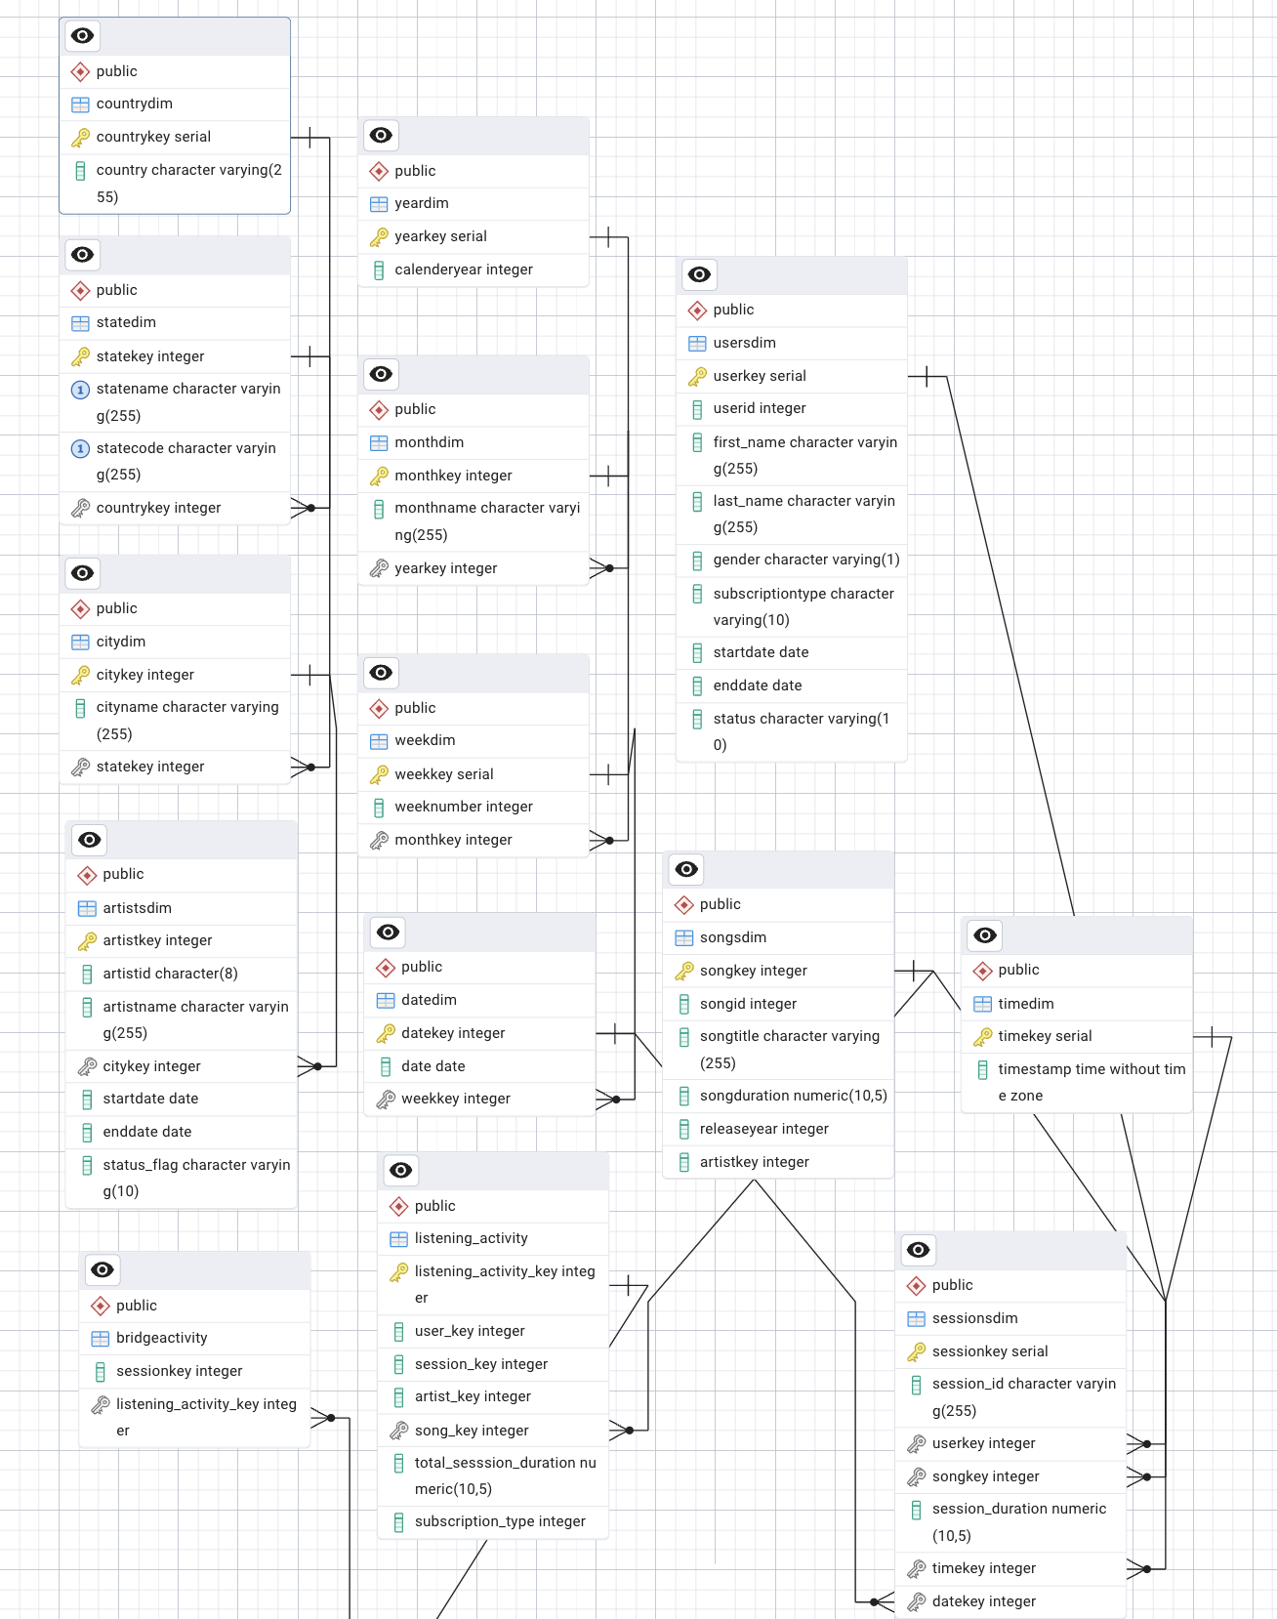

# **11.OLAP Operations**

#### **1. Total listening duration by subscription type**

Result ← ROLLUP(MusicMetrics, User.subscription_type, SUM(MusicMetrics.total_session_duration))

**Description**: Aggregates total listening duration for users categorized by subscription type (Free or Paid).

#### **2. Listening activity by gender and month**

Result ← ROLLUP(MusicMetrics, User.gender, Time.Month, SUM(MusicMetrics.total_session_duration))

**Description**: Aggregates total listening activity by gender and month for analyzing user engagement trends.

#### **3. Top cities for listening activity**

Result ← ROLLUP(MusicMetrics, Region.city_name, SUM(MusicMetrics.total_session_duration))

**Description**: Aggregates listening activity by city to determine the most active cities in terms of user engagement.

#### **4. Monthly artist performance analysis**

Result ← ROLLUP(MusicMetrics, Artist.artist_name, Time.Month, SUM(MusicMetrics.total_session_duration))

**Description**: Aggregates total listening duration for each artist by month for performance tracking.

#### **5. Listening activity by state and year**

Result ← ROLLUP(MusicMetrics, Region.state_name, Time.Year, SUM(MusicMetrics.total_session_duration))

**Description**: Aggregates listening activity by state and year to identify regional user trends over time.

#### **6. User activity by device type**

Result ← ROLLUP(MusicMetrics, User.user_agent, SUM(MusicMetrics.total_session_duration))

**Description**: Aggregates user activity based on device type (Windows, Android, Mac) to understand platform usage patterns.

# **12.Multiple Data Source Implementation in Talend Studio**

In this project, multiple data sources were integrated into Talend Studio to enhance data quality and support diverse future use cases. The original data source lacked comprehensive information, such as mapping between City and State Names, as it only contained the **City** and **StateCode** columns. To address this, an additional dictionary dataset was incorporated, consisting of a **CSV** file downloaded from a U.S. government website. This dataset provided a detailed mapping of **State Names**, **StateCodes**, and **Cities**.

Using Talend Studio, the CSV file was processed and seamlessly integrated into the ETL workflow. The tMap component was employed to perform lookups, mapping the StateCode from the original data source to its corresponding State Name. This enriched the dataset with accurate and complete geographic information, which was crucial for creating meaningful visualizations, such as choropleth maps and state-level aggregations.

This modular and scalable approach ensures the data pipeline is equipped to accommodate additional data sources in the future, such as international location mappings or updated geographic data. By establishing this flexible framework, the project not only resolved the immediate data gap but also positioned itself to adapt to evolving business needs, enabling advanced analytics and reporting use cases.

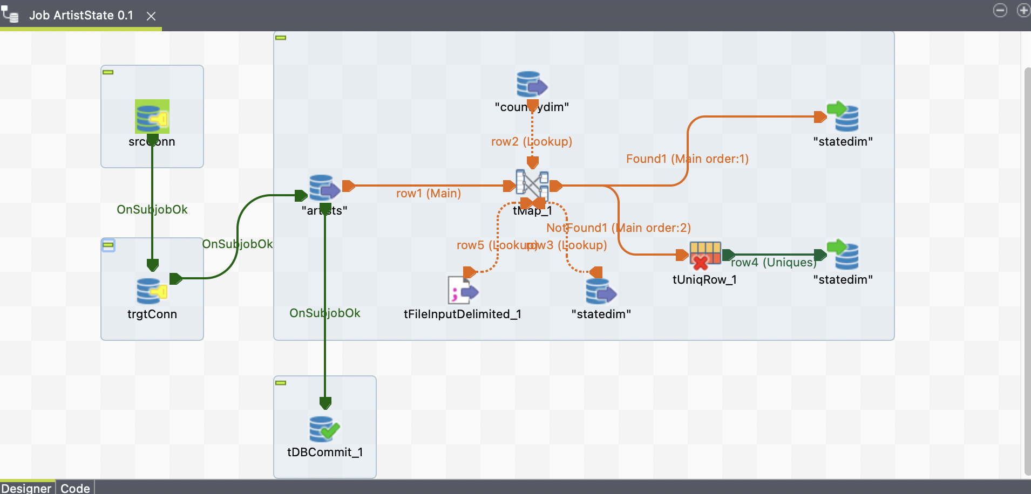

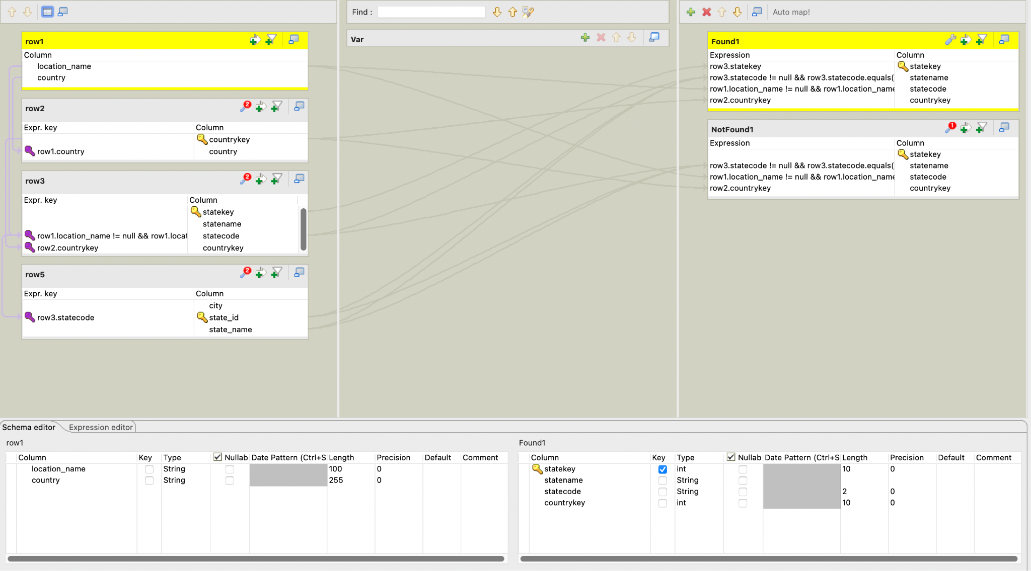

# **13.SCD Type II Implementation**

**Slowly Changing Dimension (SCD) Type 2** was implemented to effectively track historical changes in the data, particularly in the **UsersDim** table. The primary objective was to maintain a comprehensive history of user subscription details and status transitions over time. Whenever a user switched their subscription type, such as moving from a "free" to a "paid" subscription, a new record was inserted into the **UsersDim** table with updated details while preserving the previous record. This was achieved using additional columns such as **start_date** and **end_date** to indicate the validity period of each record. A **status** column was also introduced to identify whether a record is currently "**Active**" or "**Inactive**." This implementation ensured a clear audit trail of user subscription behavior, enabling accurate trend analysis and better insights into user preferences and transitions. By leveraging this approach, the data warehouse remained robust, capable of answering both historical and current data queries effectively.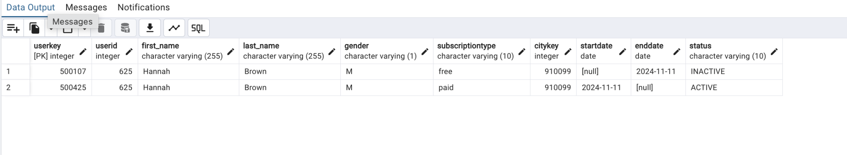

# **14.Control Flow**

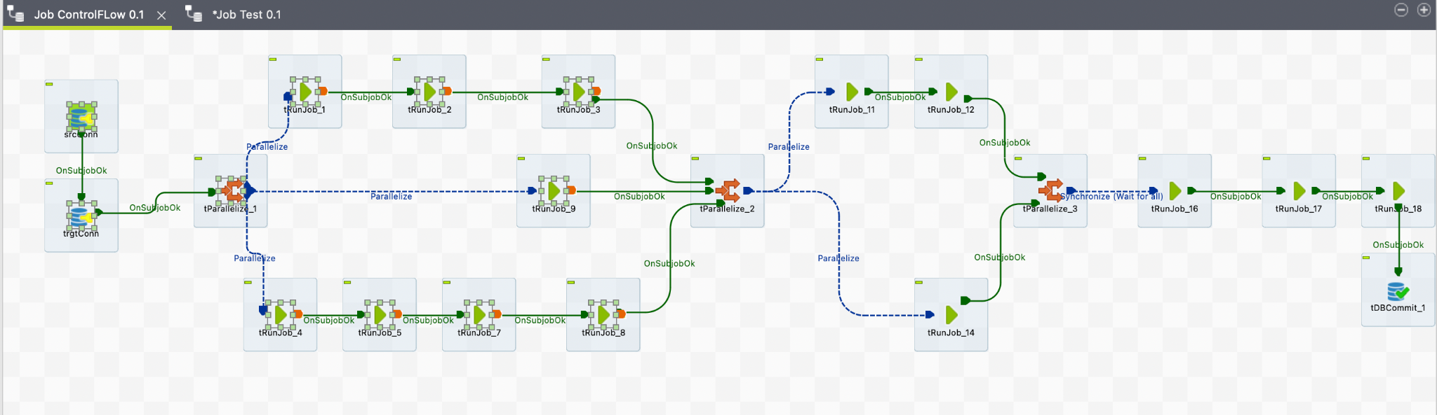

**Note: Every step of Talend ETL Execution is documented at the end**

# **15. Key Performance Indicator**

### **1. User Engagement Metrics**

* **Total Listening Duration**:
  + **Definition**: The total time users spend listening to content across all platforms, subscription types, or geographic regions.
  + **Use**: A primary indicator of user engagement and content consumption.

### **2. User Demographics and Behavior**

* **Listening Duration by Gender**:
  + **Definition**: The split of total listening duration between male and female users.
  + **Use**: Understand user engagement differences based on gender.
* **Listening Duration by User Agent**:
  + **Definition**: Total listening duration segmented by user agent (Windows, Android, Mac).
  + **Use**: Identifies which platforms or devices are more popular among users.
* **Active User Base by Subscription Type**:
  + **Definition**: The number of active users for each subscription type (Free vs. Paid).
  + **Use**: Gauge the distribution of user engagement.

### **3. Geographic Insights**

* **Top States or Cities by Listening Duration**:
  + **Definition**: Geographic regions with the highest total listening durations.
  + **Use**: Identify areas with the most user activity to target for marketing or content strategy.

### **4. Device and Technology Metrics**

* **User Agent Adoption**:
  + **Definition**: Percentage of users on each platform (Windows, Android, Mac).
  + **Use**: Understand which platforms to optimize for.

# **16.Analytical Dashboard**

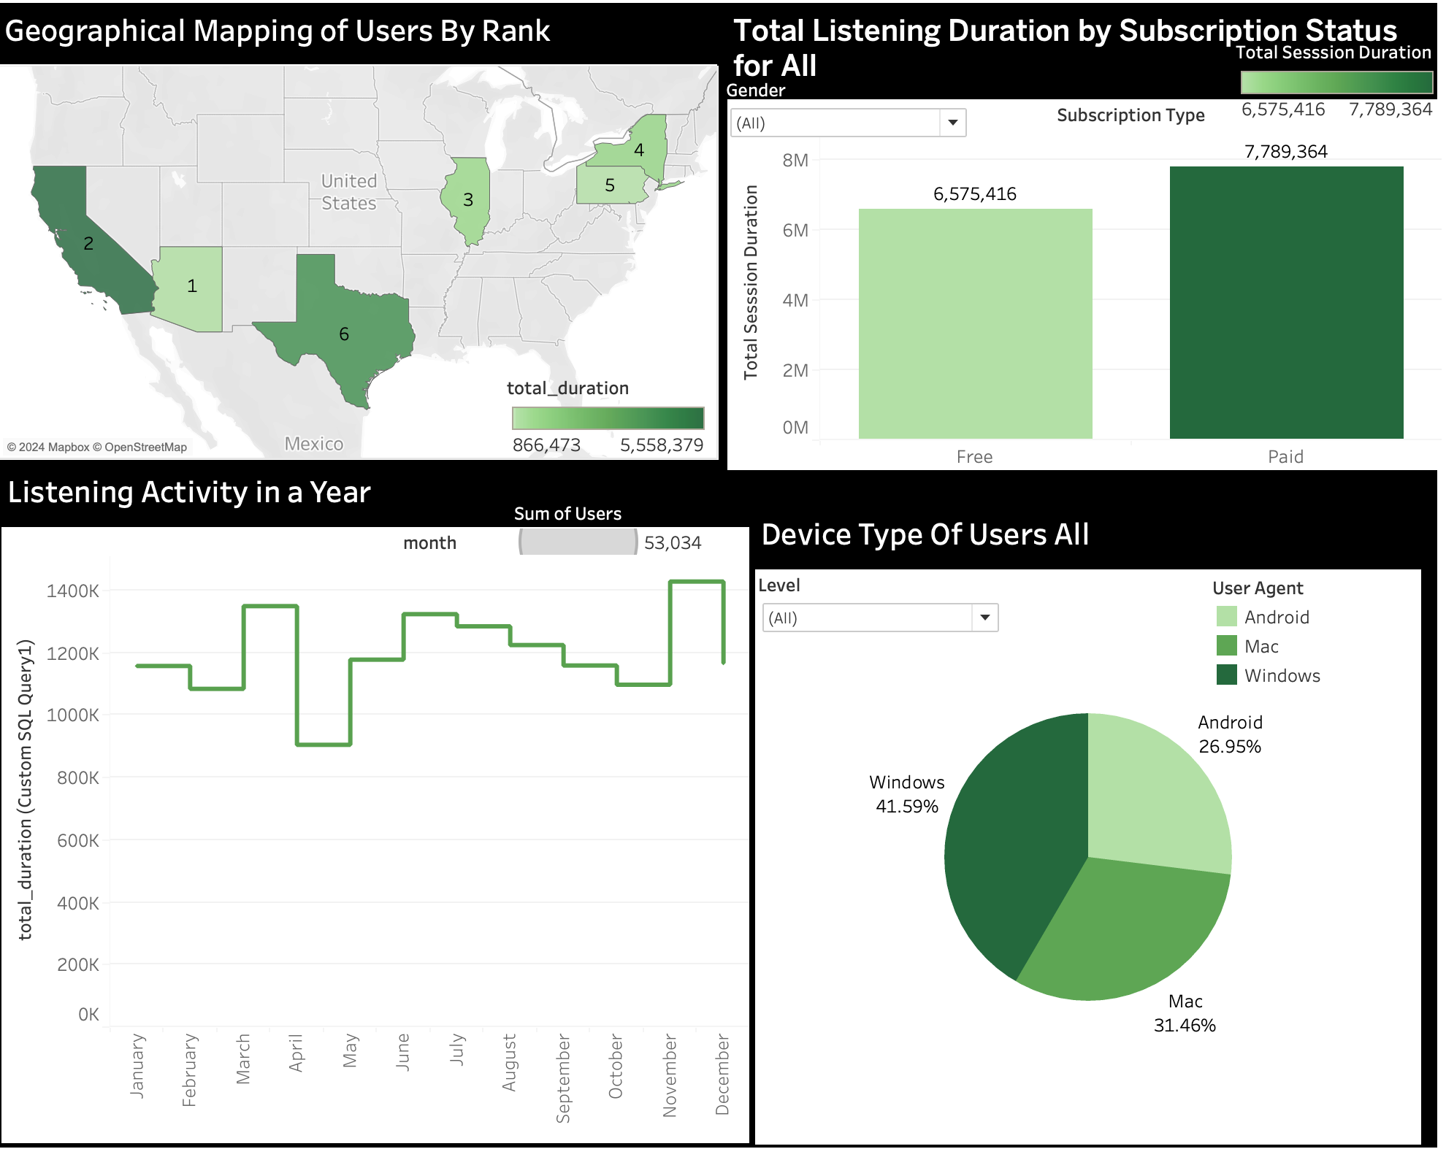

# 

# **17.Conclusion**

The implementation of the ETL process using Talend Studio for this project successfully addressed key challenges, including enriching data with additional sources, implementing Slowly Changing Dimensions (SCD) Type 2 for historical tracking, and creating robust data pipelines to populate a comprehensive OLAP data model. The integration of multiple data sources, such as city-state mappings, ensured the accuracy and completeness of the dataset, which was critical for deriving actionable insights. The resulting data warehouse supports advanced reporting and analytics, including tracking user listening behaviors, subscription patterns, and geographic trends. This scalable and flexible ETL framework lays a strong foundation for future data-driven decision-making and strategic growth.

# **18.Future Scope**

1. **Integration of Additional Data Sources:** Extend the data pipeline to include external datasets such as music genres, user reviews, or social media interactions to enable deeper insights into user preferences and trends.
2. **Real-Time Analytics:** Implement real-time streaming pipelines using tools like Kafka or Talend Data Streams to analyze user activity and trends in real time, enabling instant decision-making.
3. **Advanced Predictive Analytics:** Leverage machine learning models on the data warehouse to predict user churn, recommend songs, or optimize subscription strategies.
4. **Support for Global Expansion:** Expand the data pipeline to handle international user data by incorporating global geographic mappings and multilingual support.
5. **Performance Optimization:** Continuously monitor and optimize ETL workflows to ensure faster data processing and scalability as data volume grows.
6. **Dashboard Enhancements:** Add new interactive dashboards and visualizations for deeper insights, such as trend comparisons across time and user demographics.
7. **Data Governance and Security:** Implement robust data governance frameworks to ensure compliance with evolving regulations like GDPR and improve data security measures.

By pursuing these future directions, the project will not only remain relevant but will also evolve to meet new business challenges and emerging opportunities.

**Data Flow Implementation Followed by the Order of ETL Execution:**

Location Migration(CountryDim):

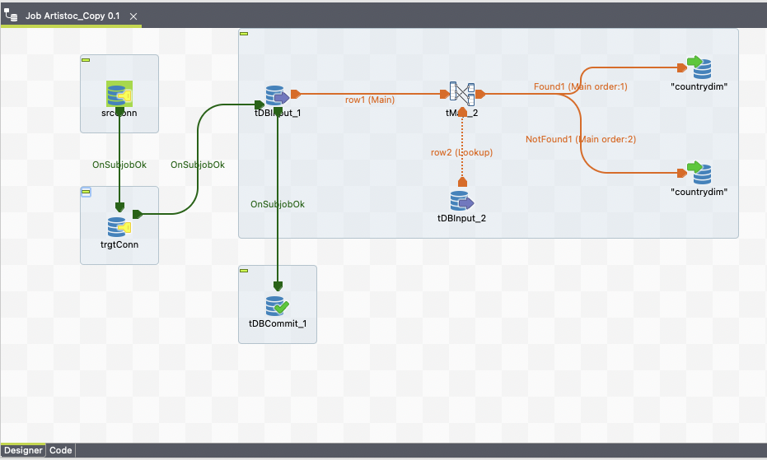  
  
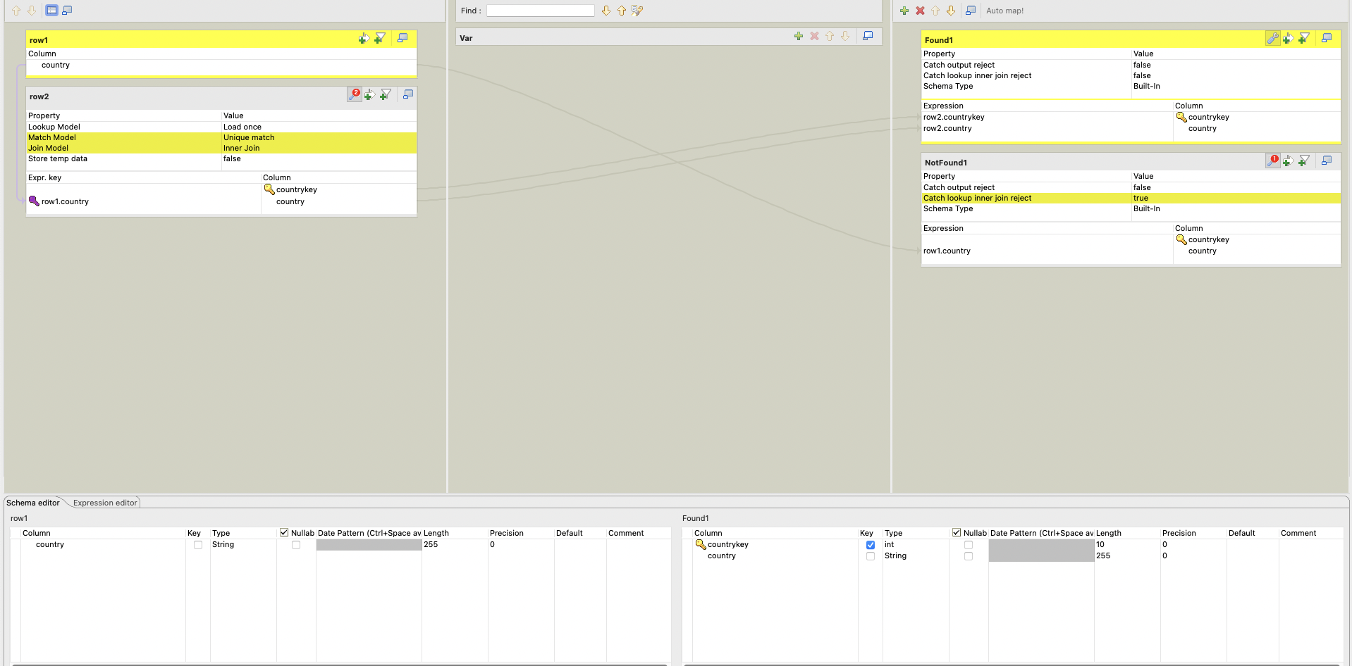

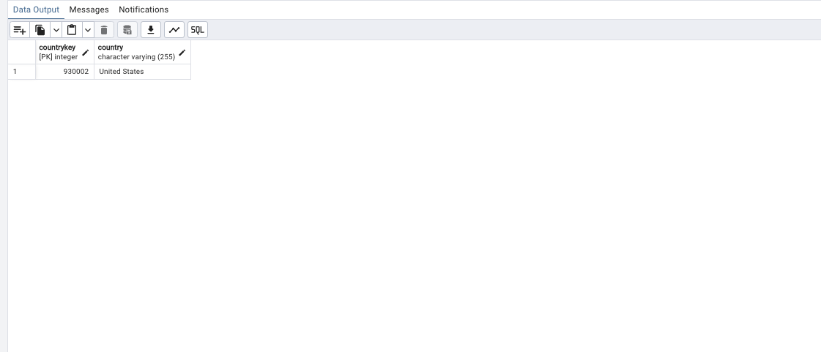

Location Migration(StateDim):

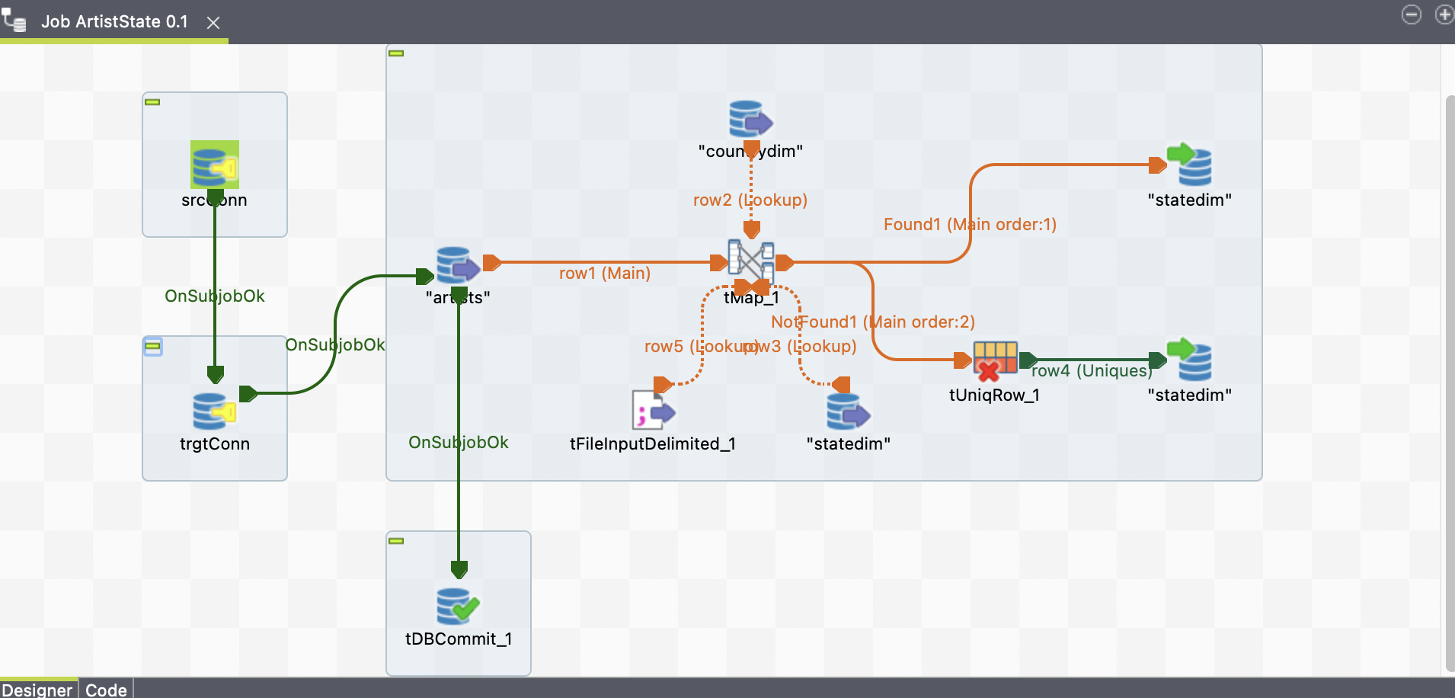

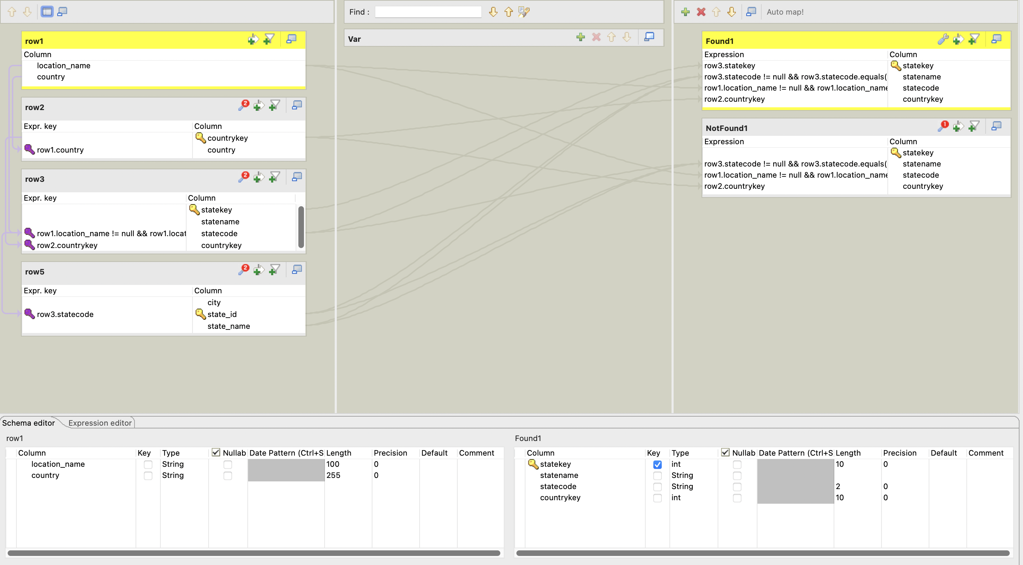

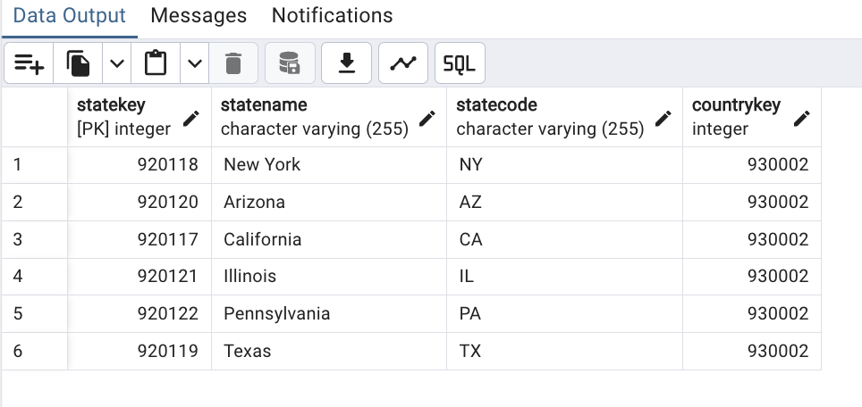

Location Migration(CityDim):

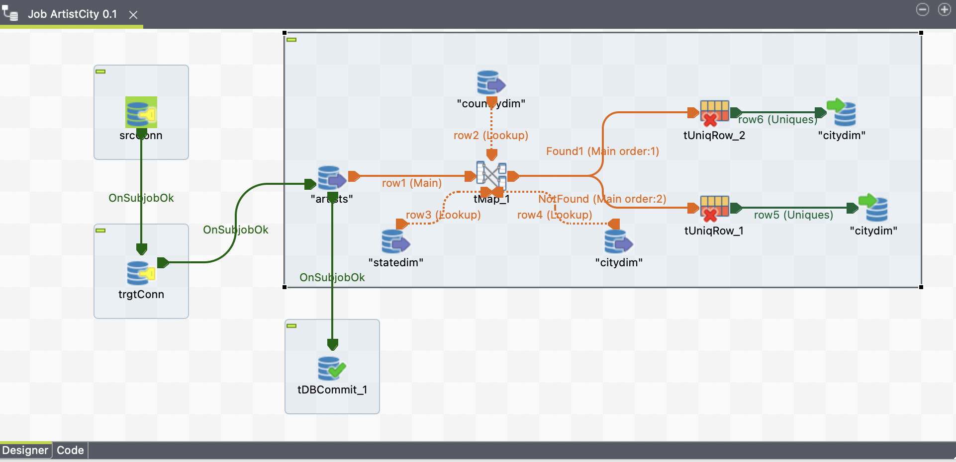

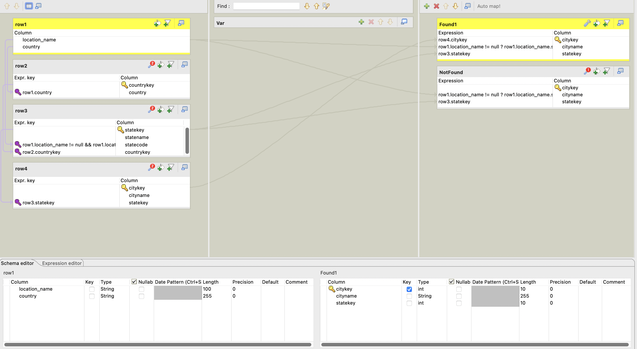

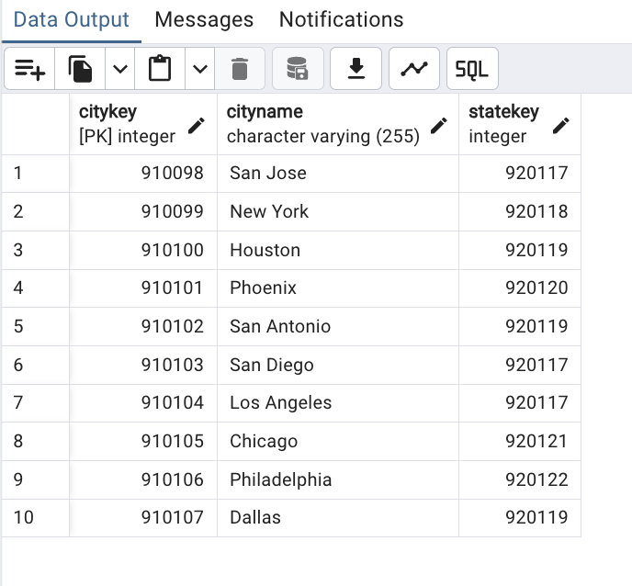

Date Migration(DateDim):

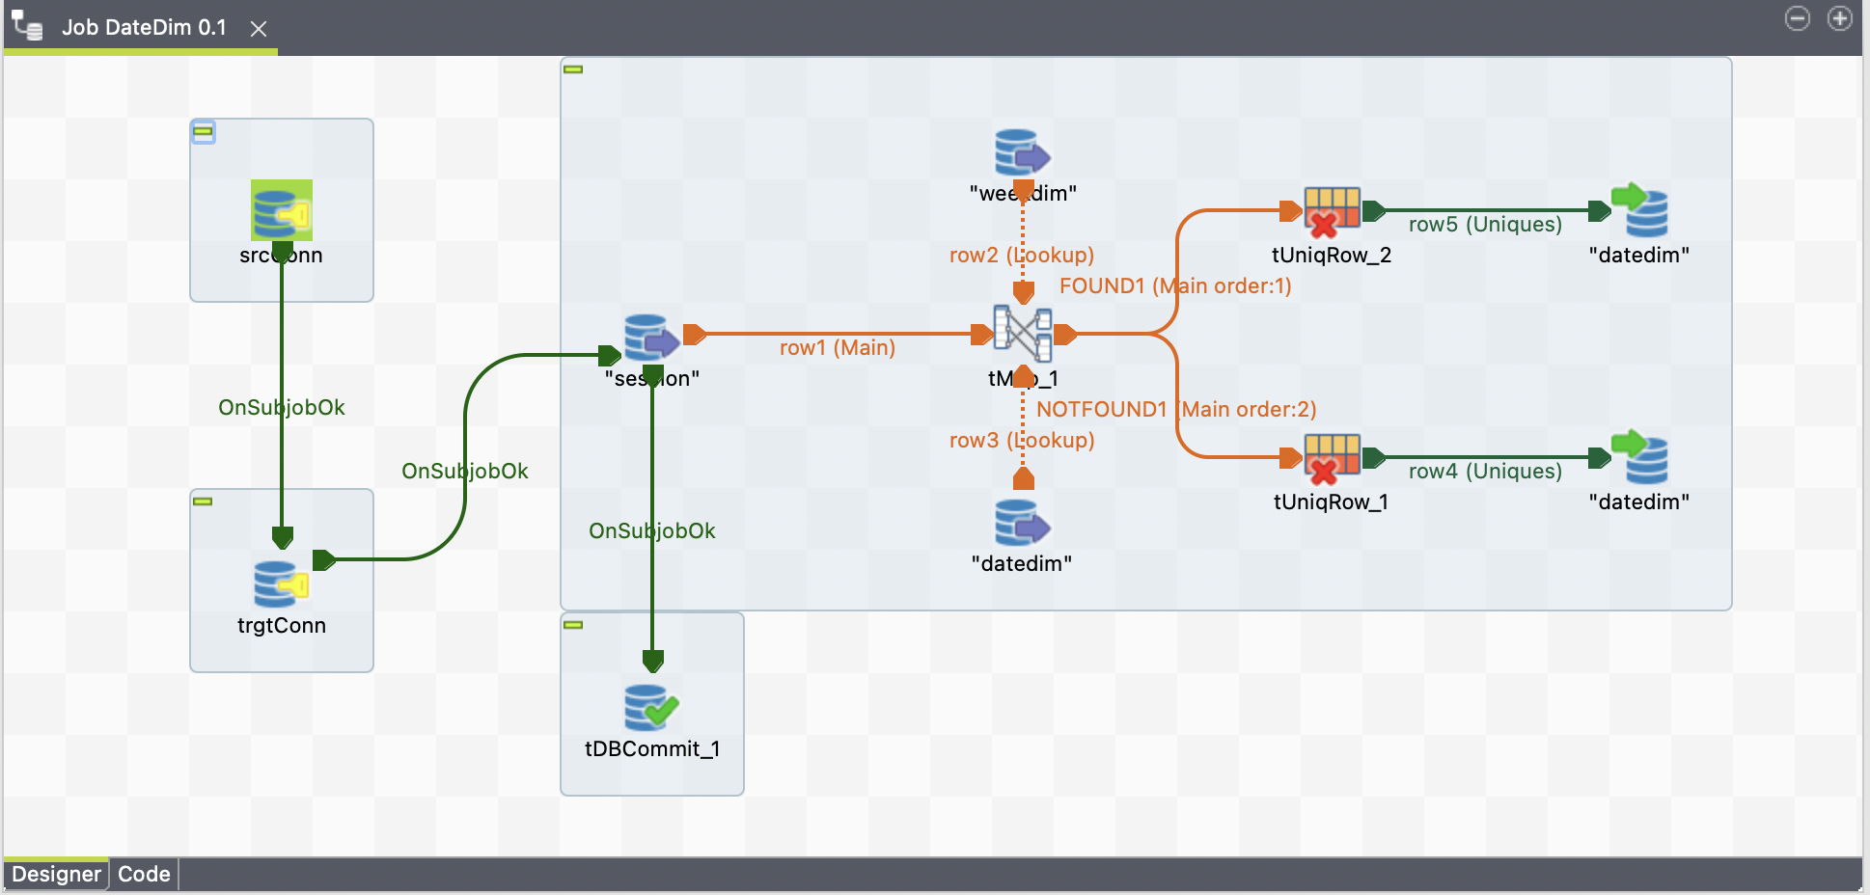

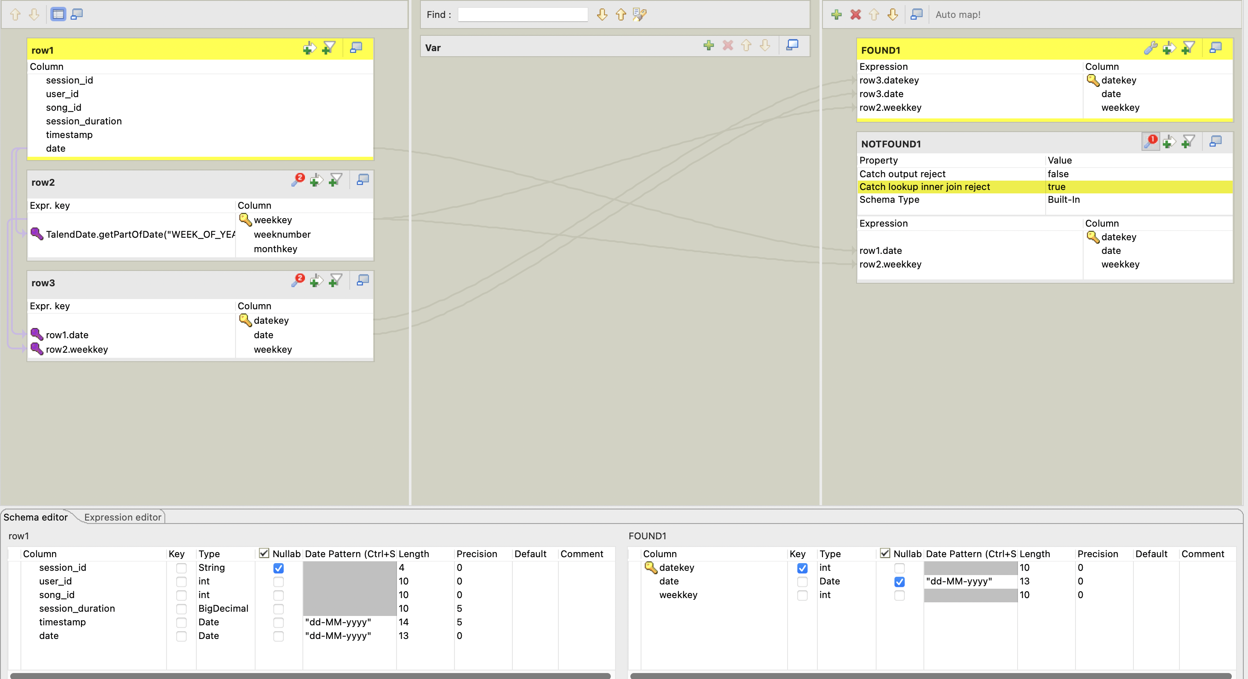

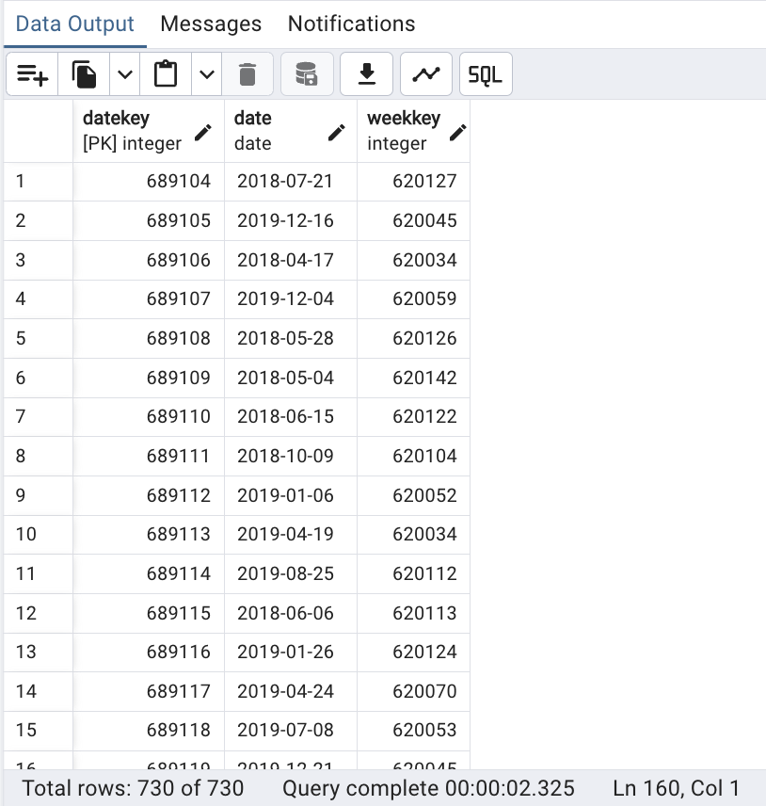

Date Migration(MonthDim):

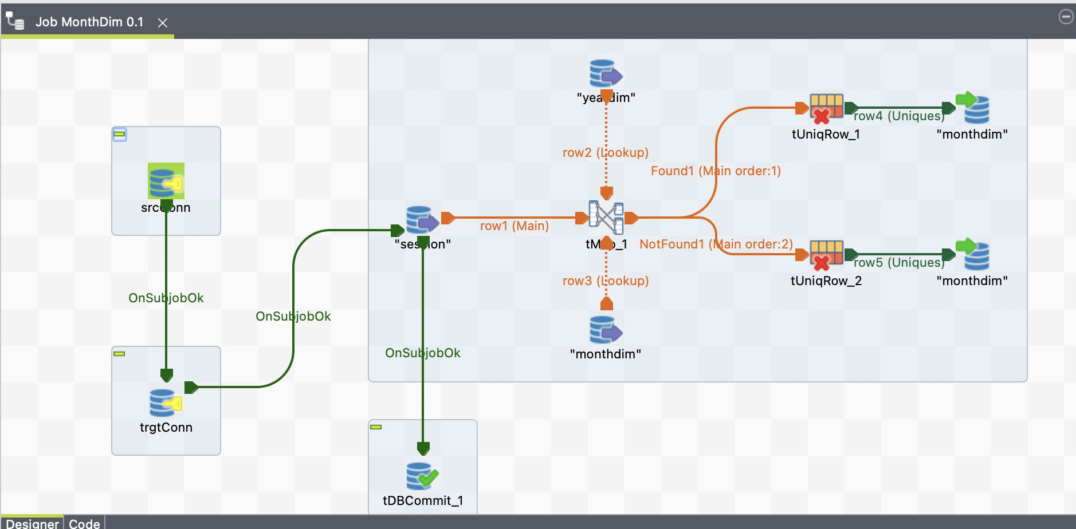

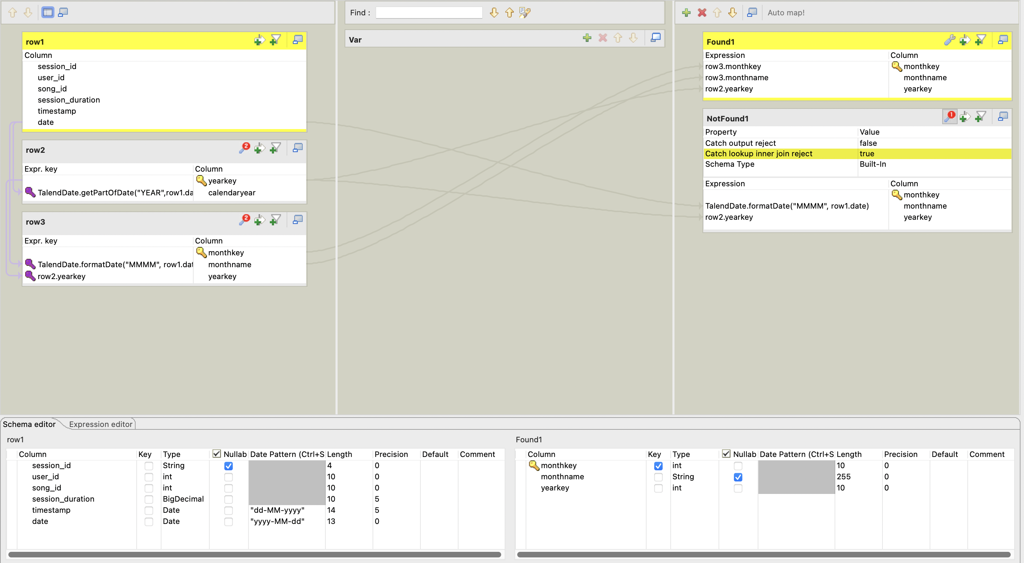

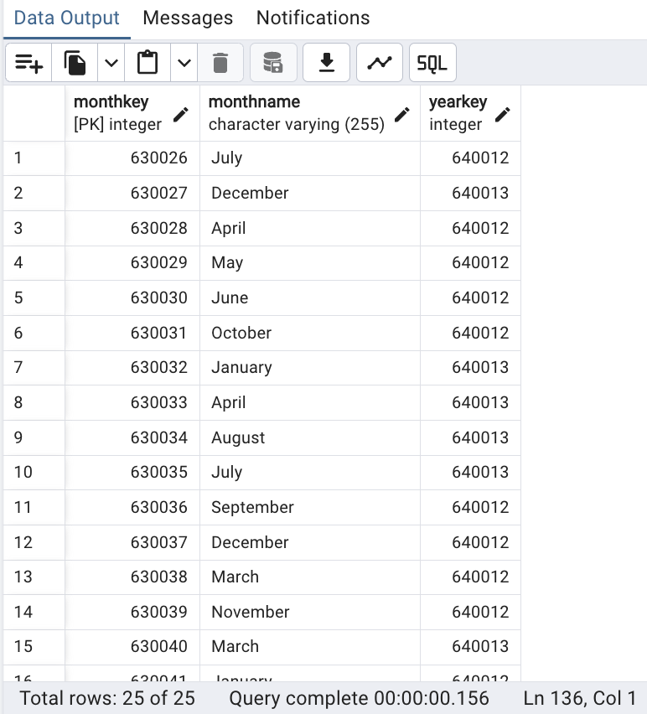

Date Migration(WeekDim): To get the week number of the year

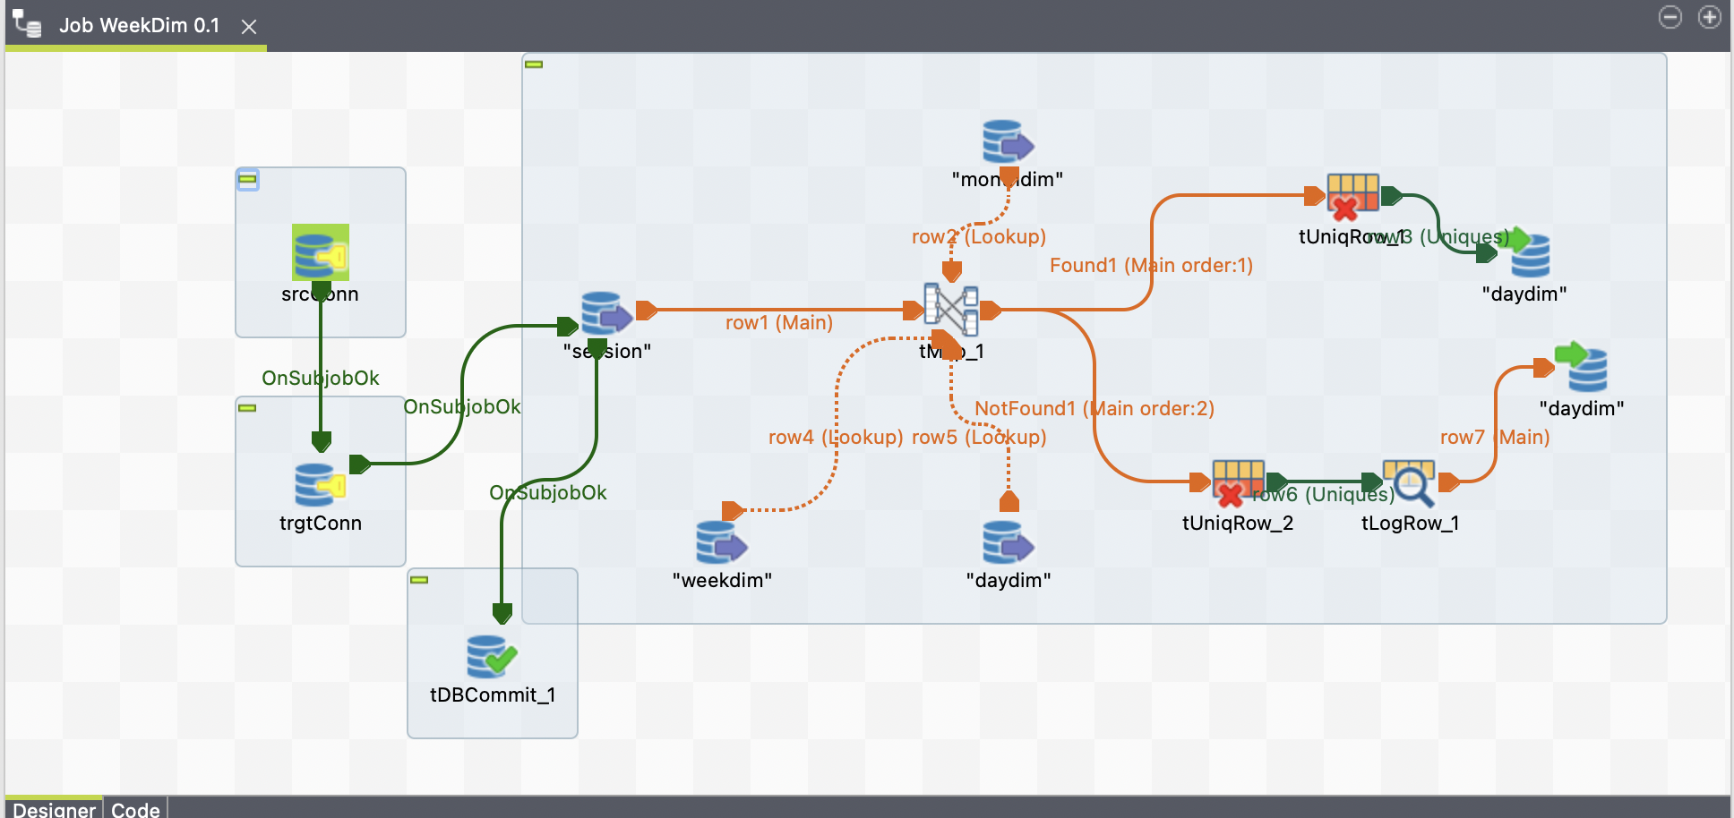

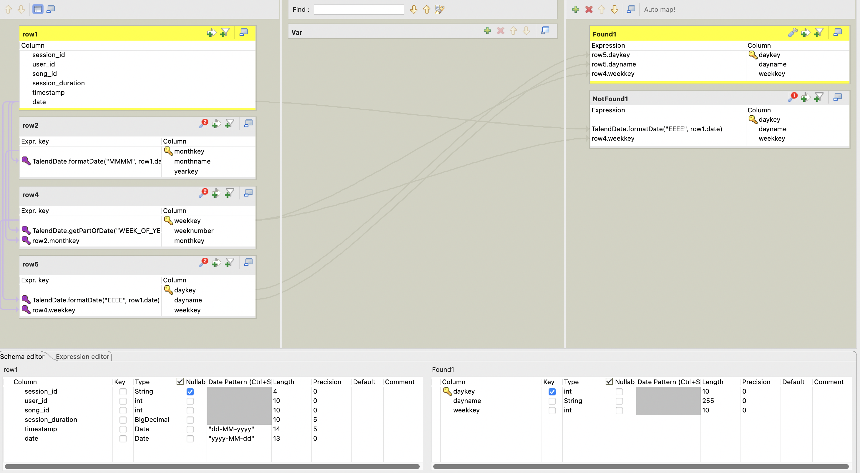

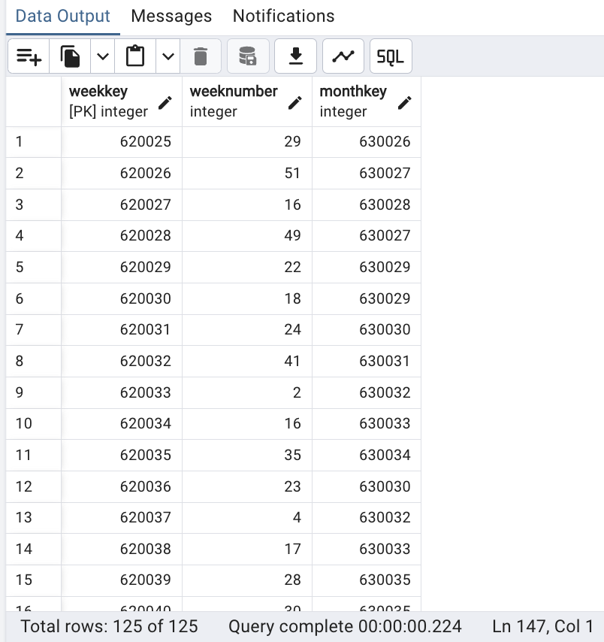

Date Migration(DateDim):

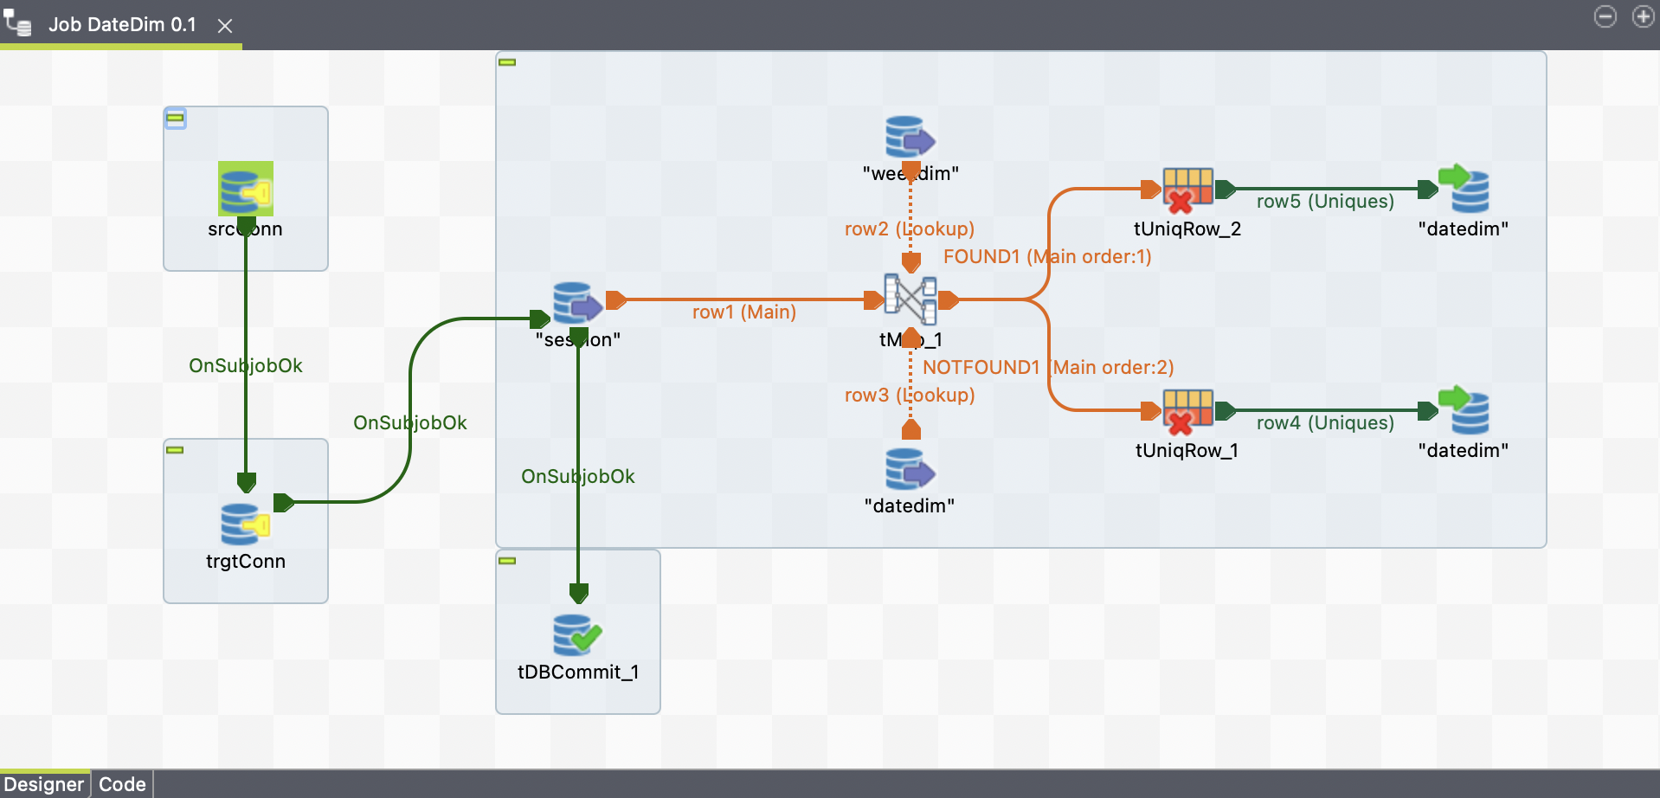

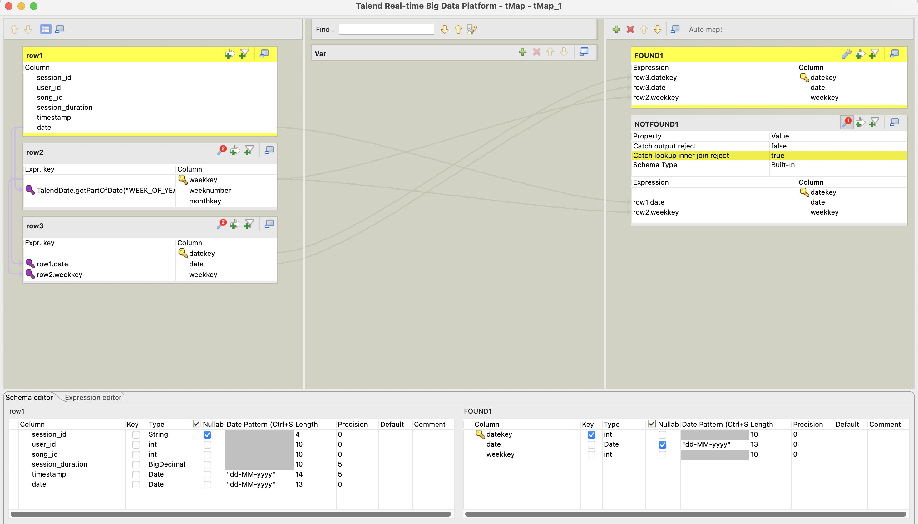

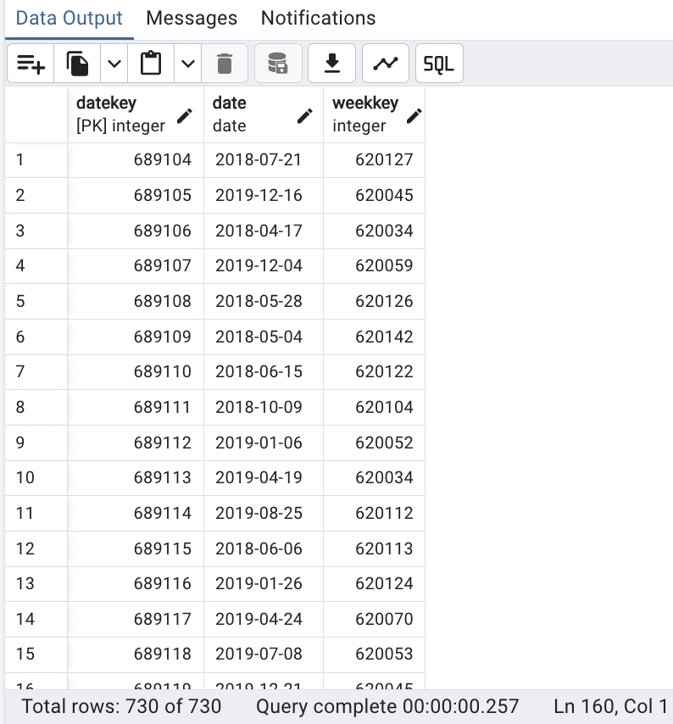

ArtsistsDim:

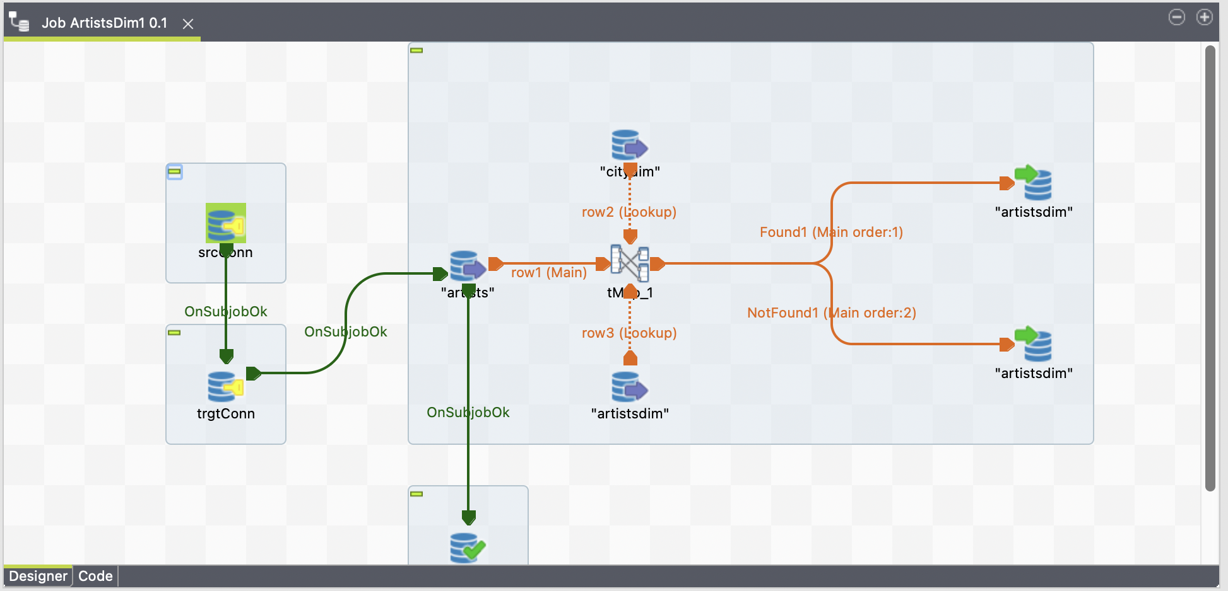

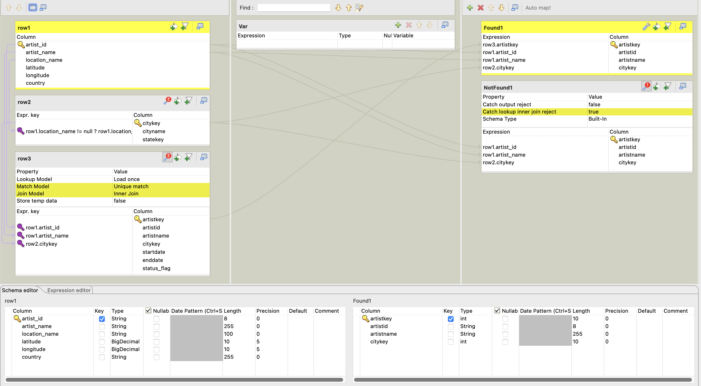

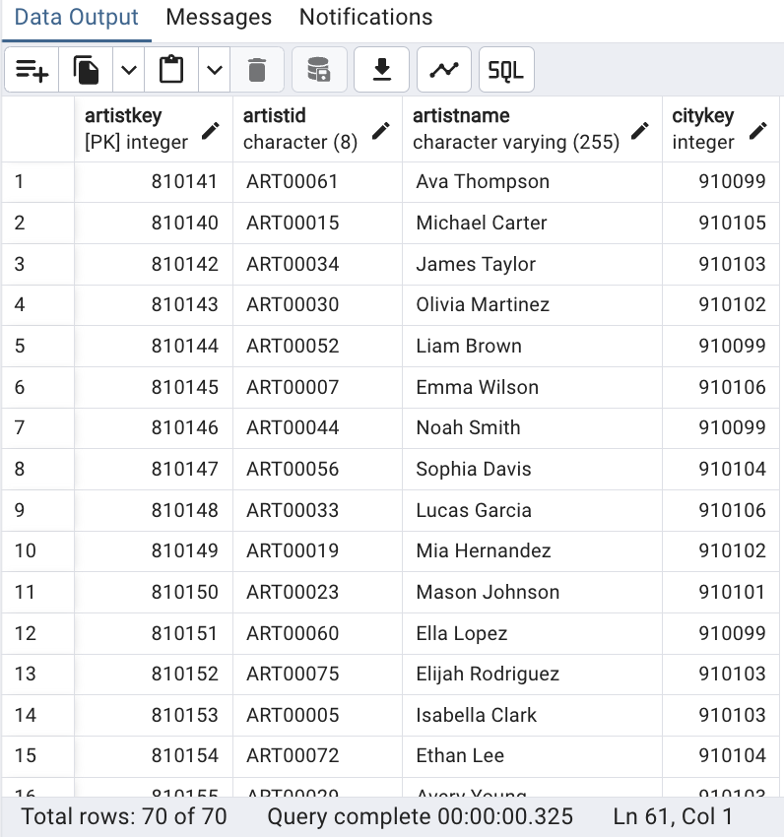

SongsDim:

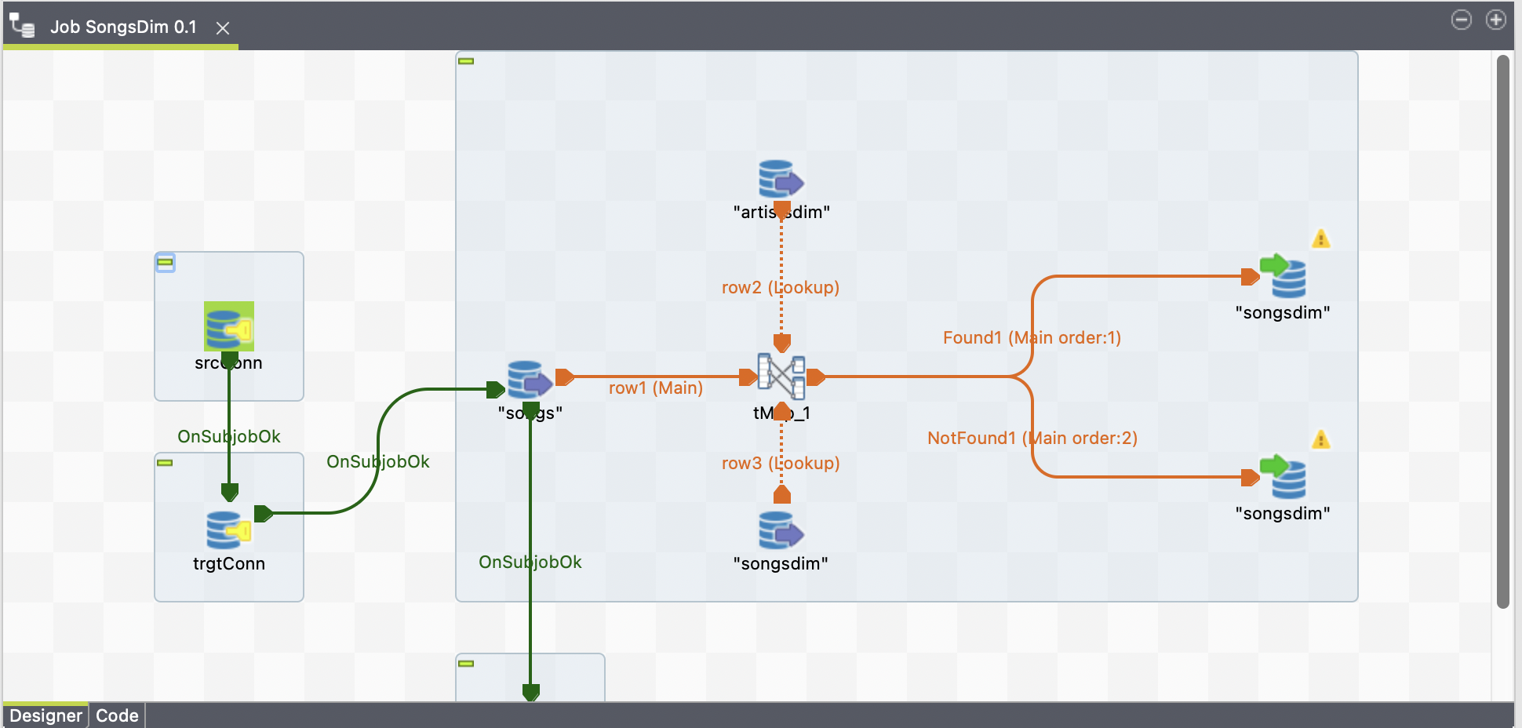

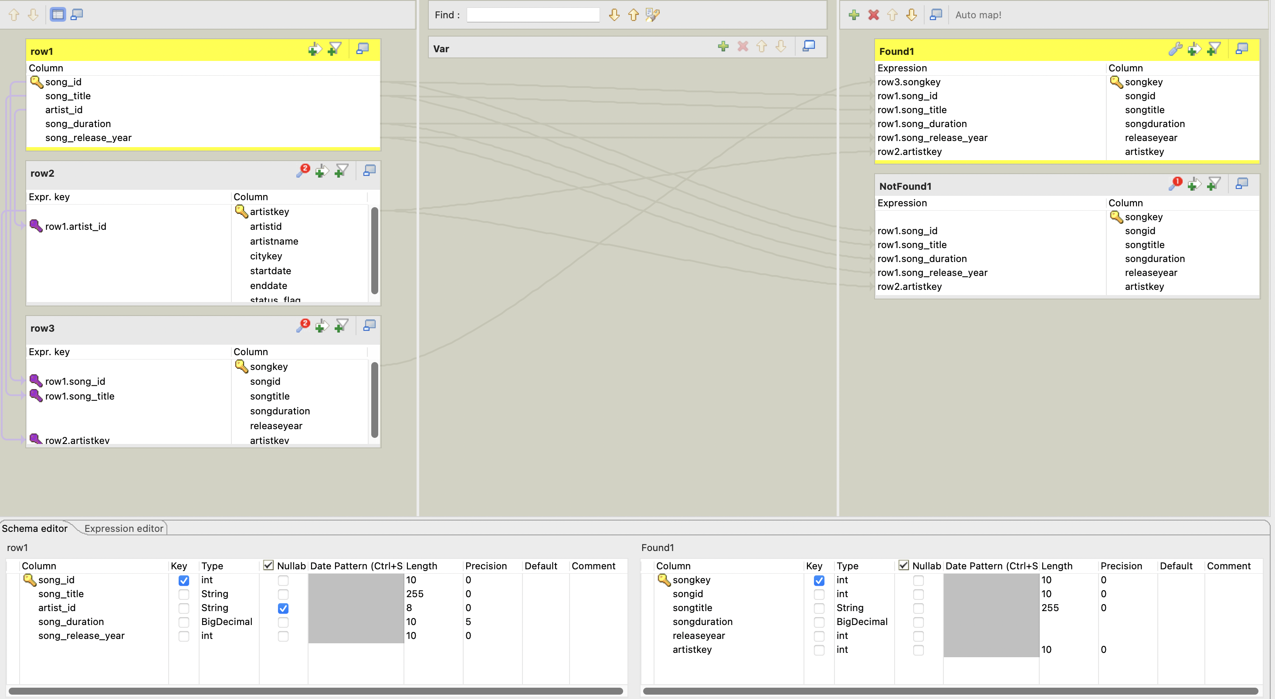

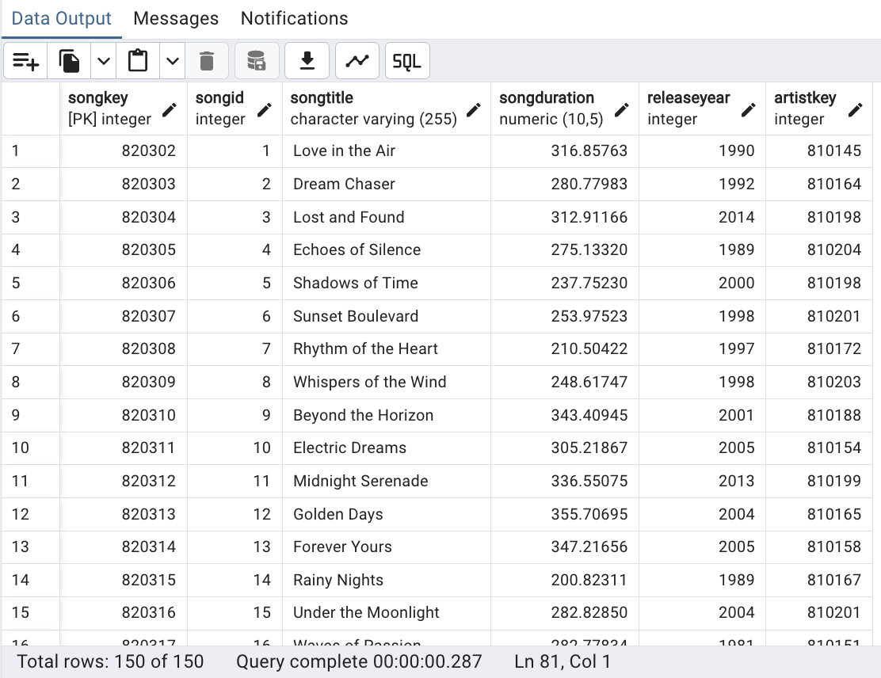

TimeDim:

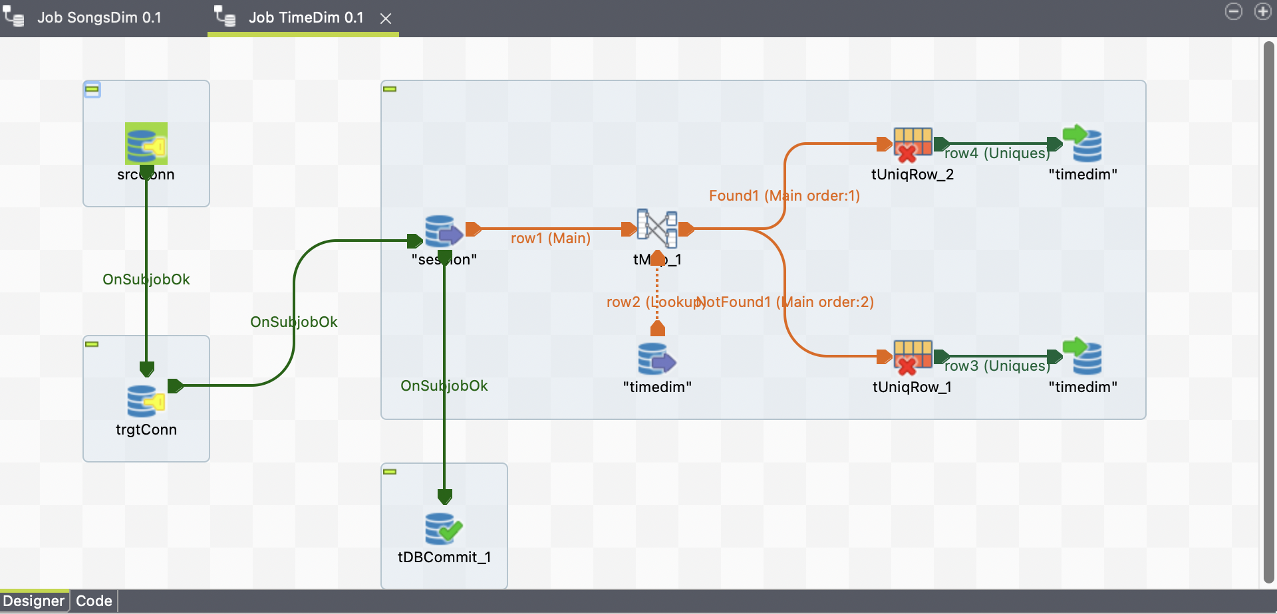

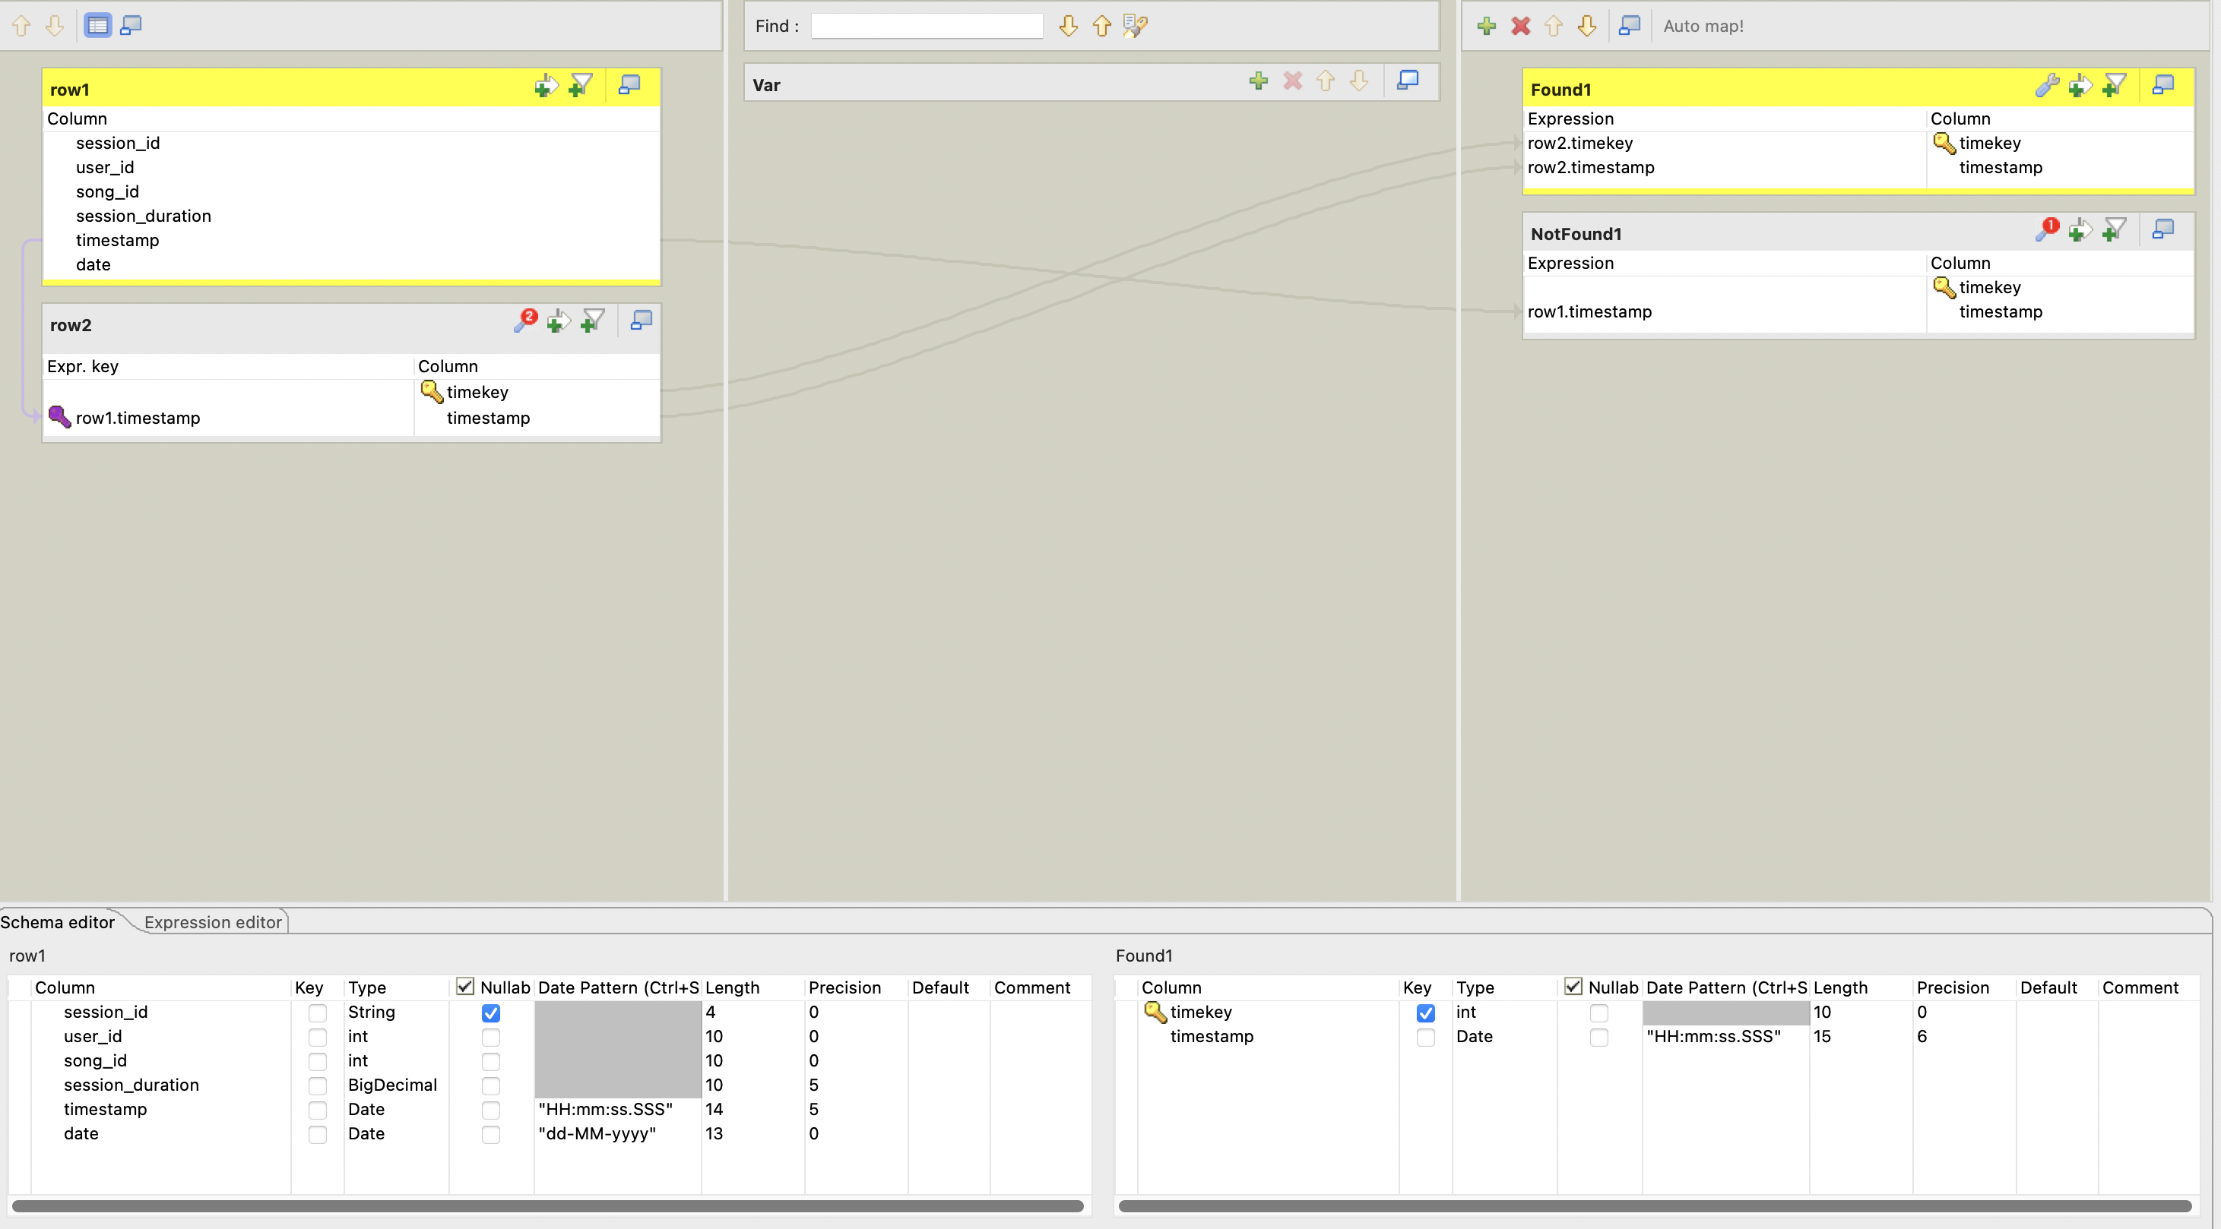

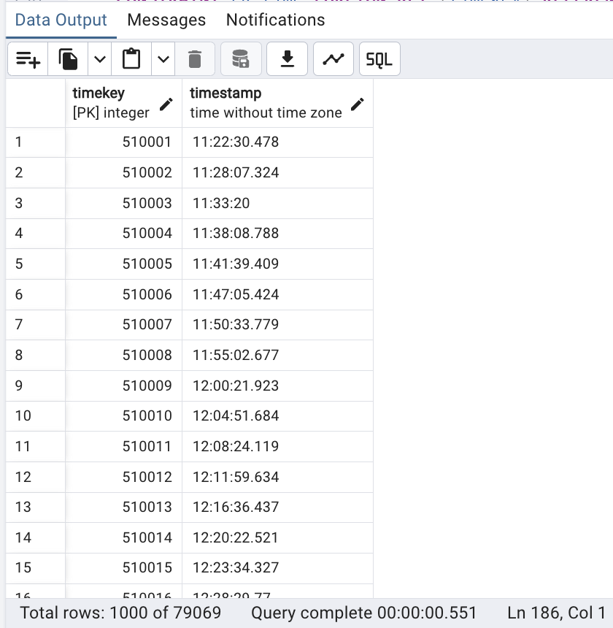

UsersDim:

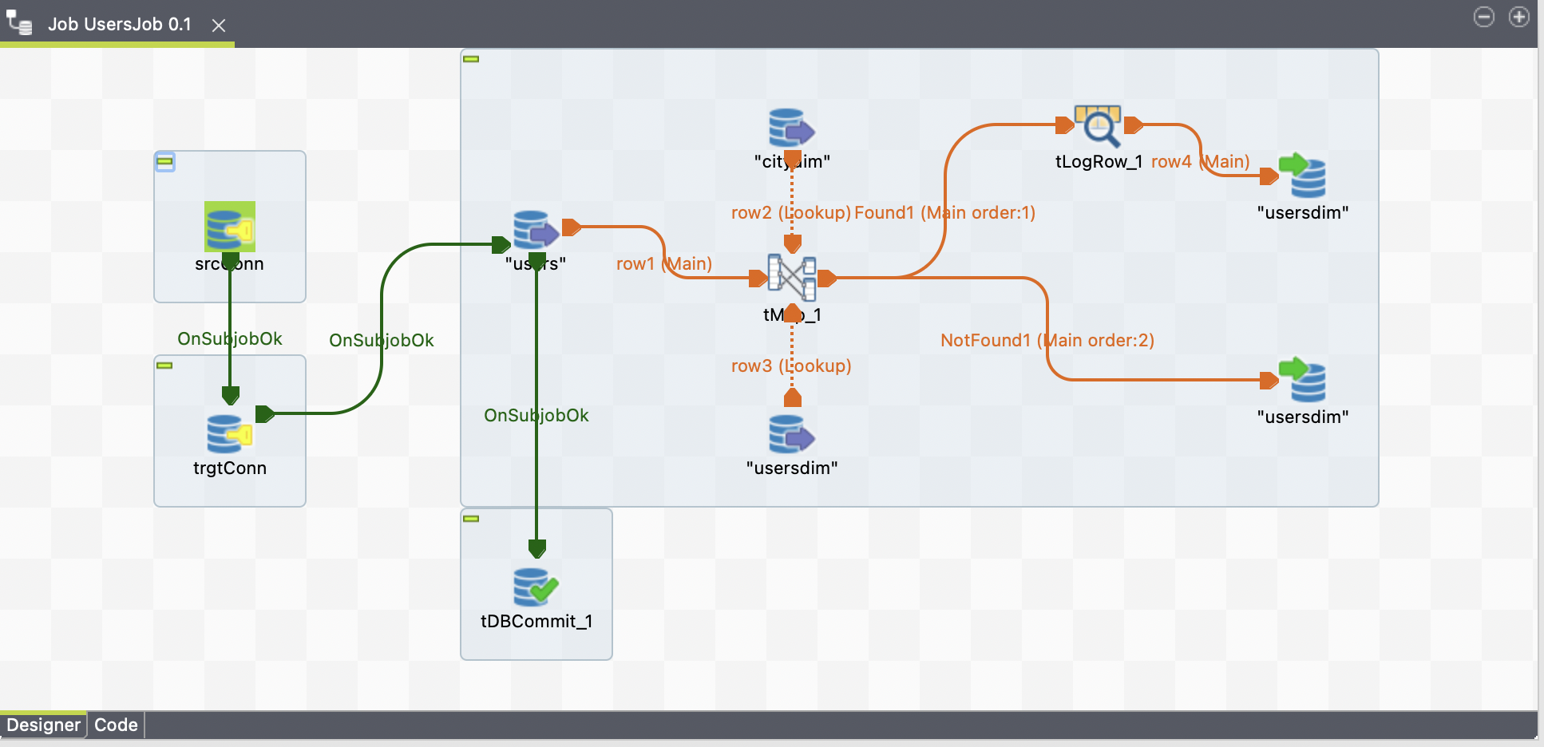

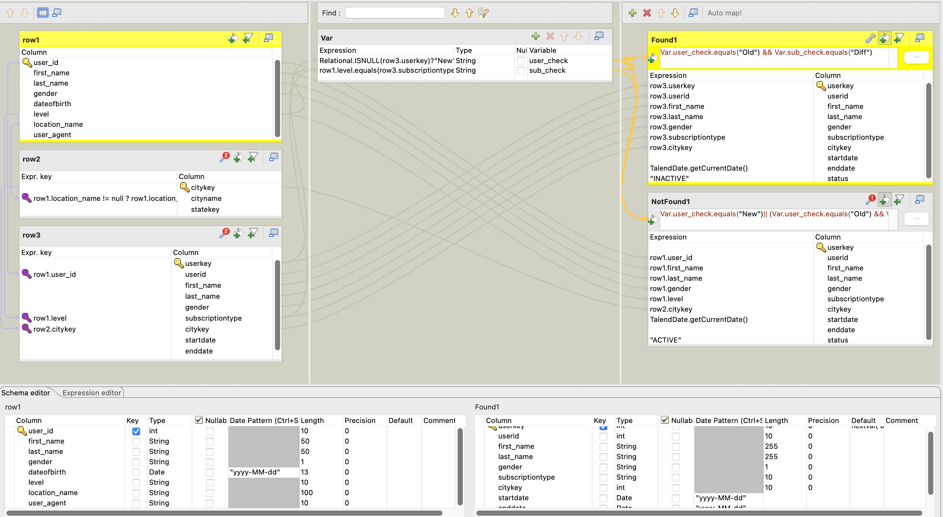

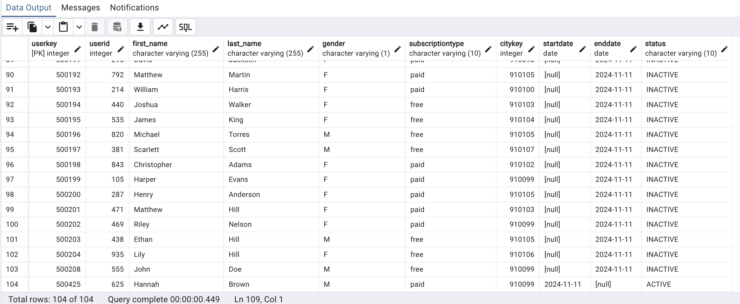

SessionsDim:

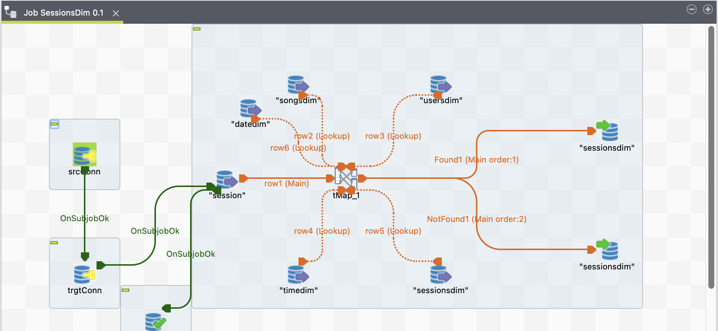

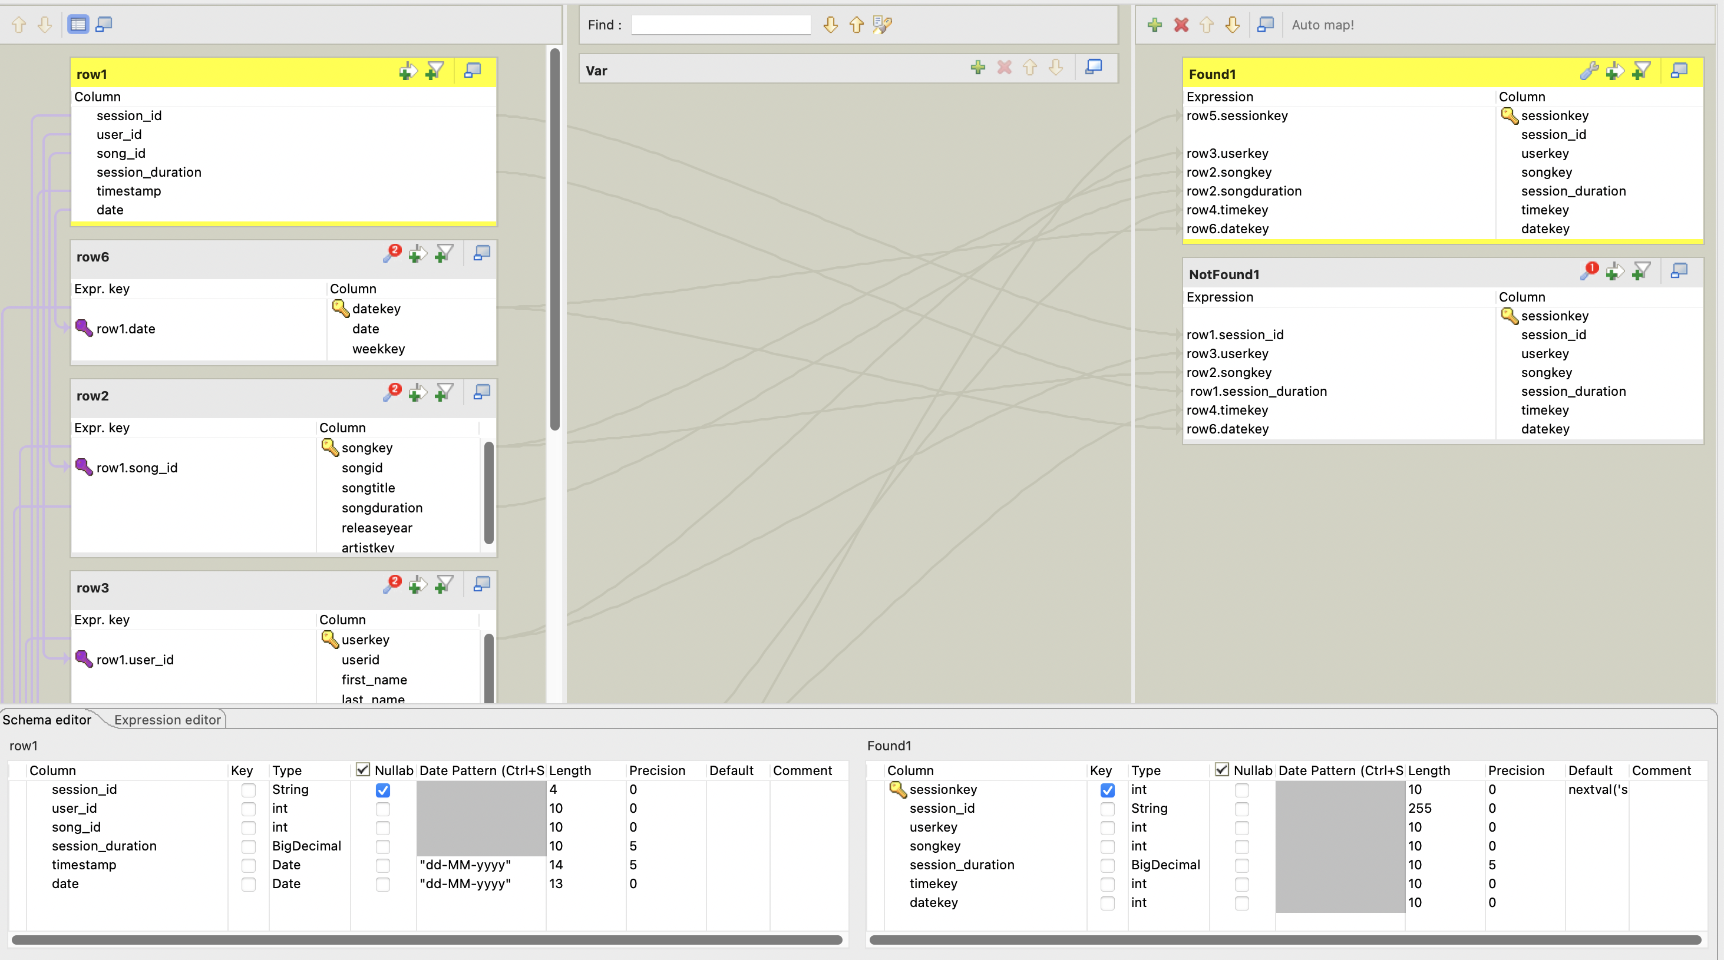

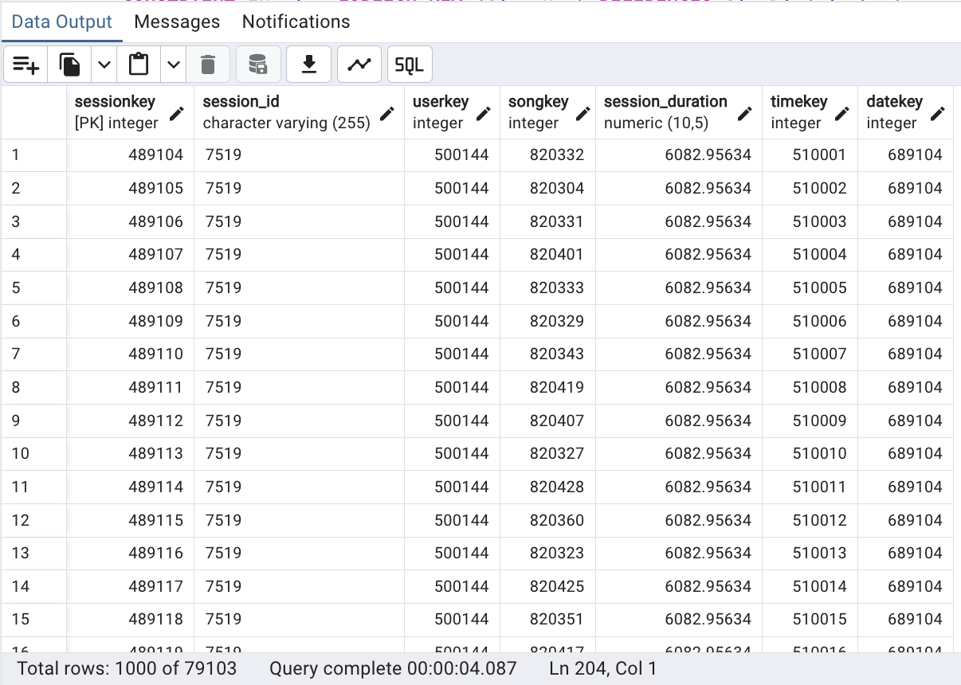

Listening_Activity(Fact Table):

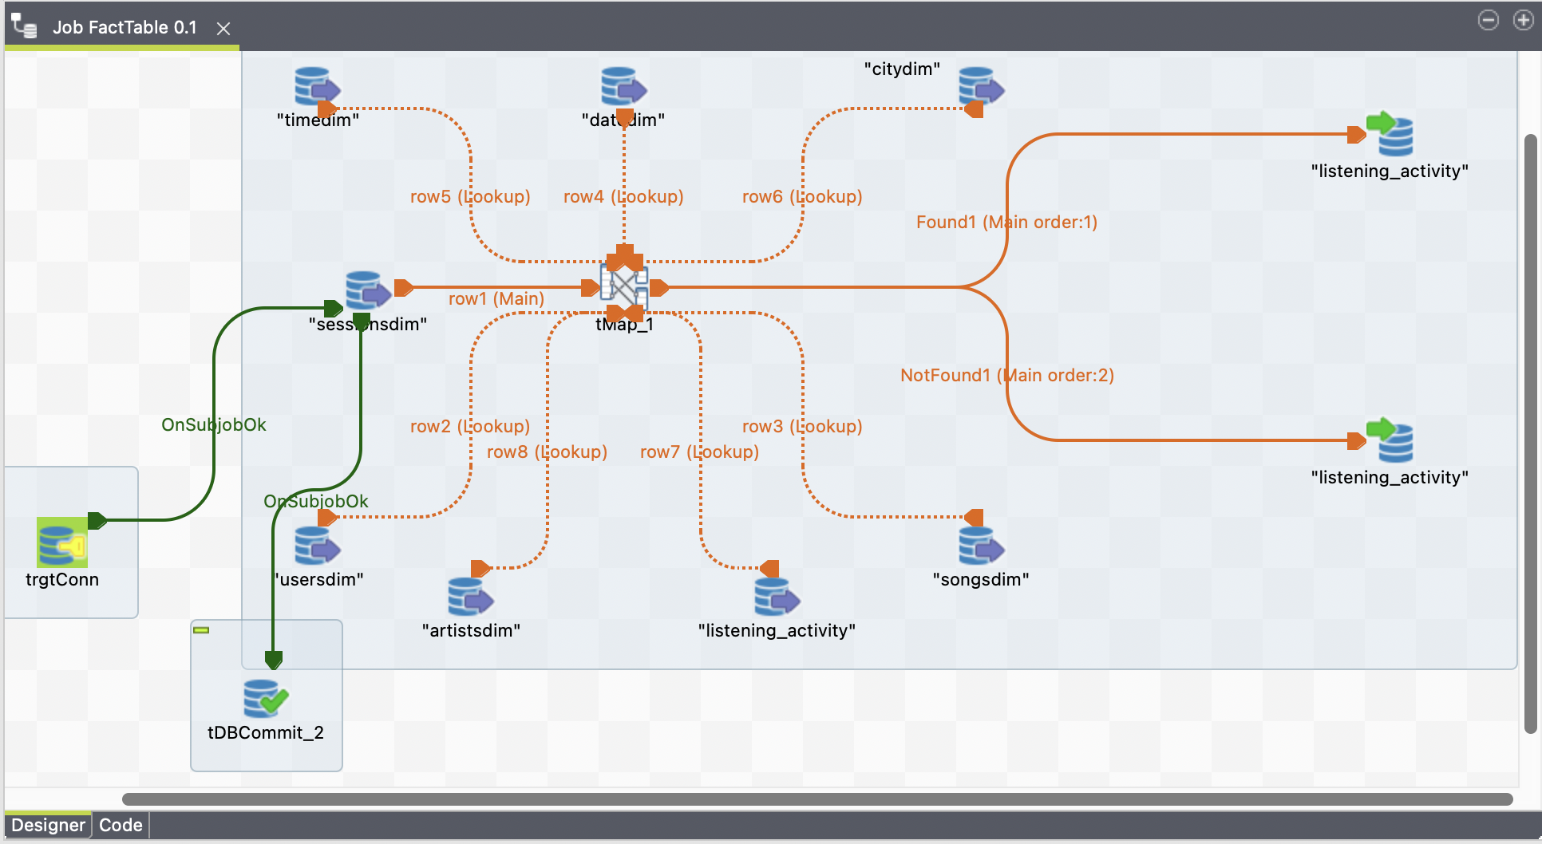

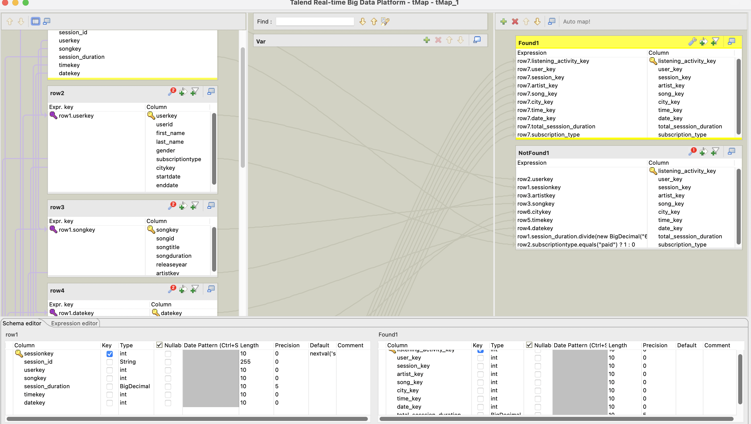

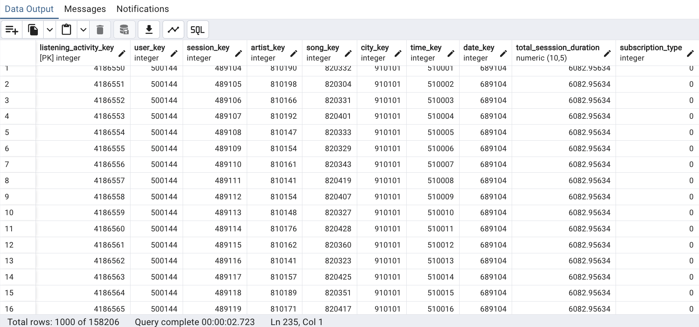

SCD type1:

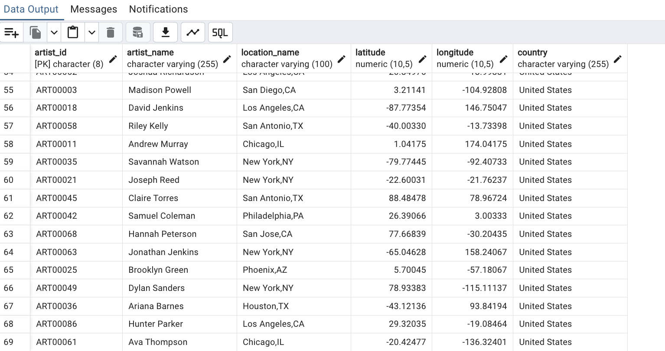

After Updating Artist location_name to a different city a new record is populated with new CityKey

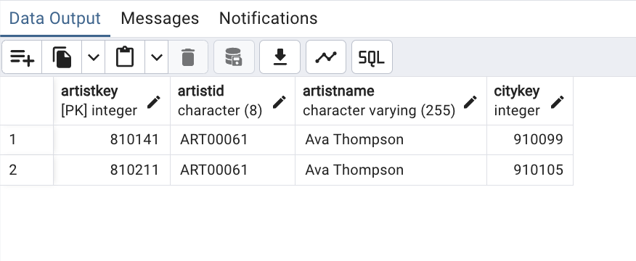

Result of SCD type2 Insatance 1:

When User subscription changes the startdate, enddate and status is updated accordingly:

